**Industrial Assessment Center**

**University of Nebraska–Lincoln (UNL)**

|  |  |
| --- | --- |
| ***Assessment Date*:** | **Tuesday, July 9th, 2019** |
| ***Client:*** | **Westin Packaged Meats** |
| ***Location:*** | **802, 810 Bacon Road**  **Fairbury, NE 68** |
| ***Principle Products:*** | **Bacon Bits** |
| ***SIC/NAICS Number:***  ***Report Date:***  ***Report Number:*** | **2011/311611**  **Tuesday, July 9th, 2019**  **NL0039** |

**Authors**

|  |  |
| --- | --- |
| **Dr. Robert Williams** | **Director (Principal Auditor)** |
| **Dr. Bruce Dvorak** | **Assistant Director (Auditor)** |
| **Sam Ghormley** | **Energy Engineer (Technical Advisor, Auditor)** |
| **Tom Fulton** | **Undergraduate Student Engineer (Lead Analyst)** |
| **Mohammad Montazeri** | **Graduate Student Engineer (Equipment Manager, Analyst)** |
| **Hannah Magill** | **Undergraduate Student Engineer (Analyst)** |
| **Carter Johnson** | **Undergraduate Student Engineer (Analyst)** |
| **Bailey Eddy** | **Undergraduate Student Engineer (Safety Coordinator, Analyst)** |



**Energy Conservation & Waste Management Assistance for Industry. Funded by the US Department of Energy’s Advanced Manufacturing Office. Additional funding from the University of Nebraska -Lincoln in support of this effort is gratefully acknowledged.**

**Preface**

The work documented in this report was performed by the Nebraska Industrial Assessment Center (NIAC), based out of the University of Nebraska–Lincoln (UNL), under contract with the Advanced Manufacturing Office of the Energy Efficiency and Renewable division of the U.S. Department of Energy. The Industrial Assessment Center (IAC) program is managed by the Center for Advanced Energy Systems, Rutgers University, Piscataway, NJ, under contract with the U.S. Department of Energy.

The objective of the IAC program is to identify and evaluate, through site visits to industrial facilities, opportunities for energy efficiency improvements, waste reduction, cyber security, and other areas pertaining to facility operations. The evaluation process is based on the data gathered during a one-day site visit and is thereby affected in detail and completeness by limitations on time at the site. In cases where assessment recommendations (ARs) involving engineering design and capital investment are attractive to a company, it is recommended that the services of an engineering consulting firm be engaged (when in-house expertise is not available) to do detailed engineering design and to estimate implementation costs. Comments regarding this assessment report and information about plans to implement the ARs identified are solicited.

**Disclaimer**

The contents of this report are offered as guidance. University of Nebraska–Lincoln (UNL), Rutgers University (the State University of New Jersey), and all technical sources referenced in the report do not: (a) make any warranty or representation, expressed or implied, with respect to the accuracy, completeness, or usefulness of the information contained in this report, or that the use of any information, apparatus, method, or process disclosed in this report may not infringe on privately owned rights; (b) assume any liabilities with respect to the use of, or for damages resulting from the use of, any information, apparatus, method, or process disclosed in this report. This report does not reflect official views or policy of the above-mentioned institutions. Mention of trade names or commercial products does not constitute endorsement or recommendation of use.

Table of Contents

1.0 Executive Summary 5

2.0 Introduction 7

3.0 Facility Background 8

3.1 Facility Description 8

3.2 General Process Description 11

3.3 Utility Usage and Applications 12

3.4 Current Energy Efficiency and Waste Management Practices 12

3.5 Major Plant Equipment 12

4.0 Utility Accounting 14

4.1 Electricity Analysis 15

4.2 Natural Gas Analysis 18

4.3 Water Analysis 20

4.4 Carbon Dioxide Analysis 23

5.0 Energy Efficiency Assessment Recommendations 24

5.1 AR No. 1: Install Capacitor Bank to Improve Facility Power Factor 24

5.2 AR No. 2: Implement A Steam Trap Maintenance Program 27

5.3 AR No. 3: Upgrade Facility Lighting 31

5.4 AR No. 4: Install Flow Restrictors in Cleaning Lines 40

5.5 AR No. 5: Repair Compressed Air Leaks 46

6.0 Appendices 52

6.1 AR No. 1 Appendices 52

6.2 AR No. 2 Appendices 53

6.3 AR No. 3 Appendices 54

6.4 AR No. 4 Appendices 58

6.5 AR No. 5 Appendices 60

***Figures (Not Including Appendices)***

**Figure 3-1:** Major Buildings Comprising Westin 8

**Figure 3-2:** Aerial Layout of Office and Main Operating Facility 9

**Figure 3-3:** Aerial View of Main Operating Facility 9

**Figure 3-4:** Main Operating Facility Layout – Detailed Plan View 10

**Figure 3-5:** General Process Flow Diagram 11

**Figure 4-1:** Westin 2018 Main Facility Utilities Summary 14

**Figure 4-2:** Westin Main Facility Addresses 14

**Figure 4-3:** Westin Entire Property Demand, April 2019 17

**Figure 4-4:** Westin 2018 Main Facility Monthly Usage vs. Demand 17

**Figure 4-5:** Westin 2018 Natural Gas Usage and Monthly HDD 19

**Figure 4-6:** Westin 2018 Main Facility Water Usage 20

**Figure 4-7:** Front Room Meter Results: Wednesday, July 10th, 2019 21

**Figure 4-8:** East Boiler Room Meter Results: Wednesday, July 10th, 2019 22

**Figure 4-9:** East Boiler Room Meter Results: Sunday, July 14th, 2019 22

**Figure 4-10:** Front Room Meter Results: Wednesday, July 10th, 2019 23

**Figure 5.1-2:** FLIR Thermal Image of Steam Trap Valve 27

**Figure 5.5-1:** Picture of Nebraska Industrial Assessment Center Intern Identifying Leak 47

**Figure 5.5-2:** Volumetric Flowrates of Air Leaks Based off Orifice Diameter obtained from the U.S. Department of Energy 49

***Tables (Not Including Appendices)***

**Table 1-1:** Overall Summary of Assessment Recommendations 5

**Table 3-1:** Summary of General Facility Information 8

**Table 3-2:** Summary of Major Processing Equipment 13

**Table 4-1:** Summary of 2018 Electric Bills 15

**Table 4-2:** Westin 2018 Electrical Load and Period Data 16

**Table 4-3:** Westin April 2019 Electrical Demand and Period Data 16

**Table 4-4:** Summary of Westin 2018 Natural Gas Utility Data 18

**Table 4-5:** Westin 2018 Monthly Heating Degree Days 18

**Table 4-6:** Summary of Westin 2018 Water Utility Data 20

**Table 4-7:** Summary of Westin 2018 CO2 Utility Data 23

**Table 5.1-1:** AR No. 1: Install Capacitor Bank to Improve Facility Power Factor Summary 24

**Table 5.2-1:** AR No. 2: Implement a Steam Trap Maintenance Program Summary 27

**Table 5.3-1:** AR No. 3: Upgrade Facility Lighting Summary 31

**Table 5.3-2:** Summary of Current Fluorescent Lighting 34

**Table 5.3-3:** Summary of Proposed Lighting 35

**Table 5.3-4:** Comparison of Current Lighting and Proposed LED Lighting 36

**Table 5.3-5:** Assumptions for Cost of Proposed LED Lighting 36

**Table 5.3-6:** Implementation Cost of Proposed LED Lighting 38

**Table 5.4-1:** AR No. 4: Install Flow Restrictors in Cleaning Lines Summary 40

**Table 5.4-2:** Summary of Current Cleaning Operations 42

**Table 5.4-3:** Summary of Proposed Cleaning Operations 43

**Table 5.4-4:** Anticipated Savings of Proposed Flow Restrictors 43

**Table 5.5-1:** AR No. 5: Compressed Air Leak Repair Summary 46

# 1.0 Executive Summary

Westin Packaged Meats is a meat packing plant specializing in the production of bacon bits and bacon flavored toppings. The property consists of multiple buildings: a main office, several cold storage areas, and a main operating facility. The main operating facility is slightly smaller than half of one city block (assuming a city block is 100,000 ft2). The NIAC team conducted an energy and waste assessment of Westin Packaged Meats’ main operating facility on Tuesday, July 9th, 2019.

The assessment of Westin Packaged Meats identified five specific recommendations the facility could implement to reduce overall operating costs. The assessment recommendations (ARs) are shown in Table 1-1 with the potential savings, capital investment, and simple payback associated with each AR listed. These ARs are listed from the greatest annual cost savings to the least. A summary of each AR is presented on the next page describing the general observations that were made and the basis of the recommendation.

**Table 1-1:** Overall Summary of Assessment Recommendations

|  |  |  |  |  |
| --- | --- | --- | --- | --- |
| **Assessment Recommendation (AR)** | **Annual Savings** | | **Capital Investment** | **Simple Payback (Years)** |
| **Resource** | **Dollars** |
| AR No. 1: Install Capacitor Bank to Improve Facility Power Factor | Unknown demand reduction (kW) | $35,066 | $39,000 | 1.1 |
| AR No. 2: Implement Steam Trap Maintenance Program | 15,697 MMBtus | $13,023 | $110 | 0.0 |
| AR No. 3: Upgrade Facility Lighting | 175,543 kWh | $12,538 | $7,282 | 0.6 |
| AR No. 4: Install Flow Restrictors in Cleaning Lines | 2,730,000 gallons | $7,716 | $1,127 | 0.2 |
| 716 MMBtus |
| AR No. 5: Repair Compressed Air Leaks | 126,284 kWh | $4,921 | $1,600 | 0.3 |
| **Total Sum**\* | **301,827 kWh** | **$73,264** | **$49,124** | **0.7** |
| **16,413 MMBtus** |
| **2,730,000 gallons** |
| *The overall payback was calculated based on the total sum of all capital investments divided by the total sum of dollar savings from all the recommendations | | | | |

**Assessment Recommendation Description:**

*AR No. 1: Install Capacitor Bank to Improve Facility Power Factor*

Fairbury Light and Water, Westin Packaged Meats’ electricity provider, charges facilities for power factor insufficiencies below the community standard of 0.95. Although Westin is not currently being charged for having an average power factor of 0.77 (below standards), it is recommended they install a capacitor bank to optimize their power factor to 0.98 and avoid the fee. Installing a capacitor bank in these conditions will cost $39,000 and will save at least **$35,066/year**. Based on this analysis, the project will be worth what it costs in **1.1** **years**.

*AR No. 2: Implement A Steam Trap Maintenance Program*

A steam line used to cook raw meat runs through the cook room at the Westin Packaged Meats main operating facility. Due to the clogging of a steam trap, a valve was left open. By implementing a $110 steam trap maintenance program, Westin can expect to save 15,697 MMBtus/year and **$13,023/year**. This program will pay for itself in approximately **3 days**.

*AR No. 3: Upgrade Facility Lighting*

Westin Packaged Meats currently illuminates 60% of their property with LED lights, spanning 4 electric meters. The remaining 40% of lighting is comprised of various fluorescent and halogen bulbs. If Westin spends $7,282 on LED lighting equivalents to replace non-LED bulbs, they will save 175,543 kWh/year and **$12,538/year**. The replacement will save Westin Packaged Meats 29 kW in demand per month and will pay for itself in **0.6 years**.

*AR No. 4: Install Flow Restrictors in Cleaning Lines*

There are currently 13 cleaning stations that use hot water throughout the main operating facility. It is recommended Westin Packaged Meats installs nozzle flow restrictors to restrict the flow of hot cleaning water from 8 gal/min to 6 gal/min. Implementing this recommendation will cost $1,127 and will save Westin **$7,716/year**, 2,730,000 gallons/year, and 716 MMBtus/year. This will pay itself back in **0.2 years**.

*AR No. 5: Repair Compressed Air Leaks*

The main operating facility utilizes a 120hp air compressor to power an air distribution system for use in many different applications of the production and packing processes. The Nebraska Industrial Assessment Center (NIAC) team has identified leaks within this system that cost Westin approximately 11% of their total annual electric bill. Implementing a leak prevention program and fixing the identified leaks will cost about $1,600 and will save Westin 126,284 kWh/year and **$4,921/year.** This will pay itself back in **0.3 years**.

# 2.0 Introduction

The contents of this report describe how energy is used throughout the plant and includes specific recommendations on cost effective changes that could reduce energy usage, cut back on waste disposal, and improve productivity. A 1-day site visit was conducted on Tuesday, July 9th, 2019 in which specific data were collected for analysis of the plant. The following report is divided into six major sections which are briefly described below.

1. **Executive Summary:** An overview of the assessment including recommendations, potential cost and energy savings., and simple payback periods.
2. **Introduction:** Describes the purpose, contents, and overall organization of the report
3. **Facility Background:** A description of the facility and its main operations, which includes the process flow to produce bacon bits and layouts of facilities comprising the Westin Packaged Meats property. This section also includes a list of major plant equipment and current energy-saving processes Westin Packaged Meats practices.
4. **Energy Accounting:** Entails the analysis and summary of all energy bills associated with facility. Costs for electricity usage and demand were obtained from the rate schedule and used for calculating potential savings. Analysis was also conducted with gas bills in conjunction with local weather data. Water bills and flowmeter data comprised water use analysis, and CO2 usage is based on bills from Westin Packaged Meats’ provider.
5. **Assessment Recommendations:** Describes the specific, quantified recommendations for the facility to investigate implementing. Each recommendation provides a background description of the specific focus area being investigated, what is being recommended, and what data was collected. The methods for calculating savings and any assumptions are clearly stated. Implementation costs and simple payback were also provided for each recommendation.
6. **Appendix:** The appendix section includes appendices for each assessment recommendation (AR) detailing pricing and quote information from vendors used in calculations for paybacks as well as other material relevant to the assessment.

# 3.0 Facility Background

## 3.1 Facility Description

**Table 3-1:** Summary of General Facility Information

|  |  |  |  |
| --- | --- | --- | --- |
| **SIC Number:** | 2011 | **Location:** | Fairbury, NE |
| **NAICS Number:** | 311611 | **# of Employees:** | 137 |
| **Annual Sales:** | $60,000,000 | **Audit Date:** | 07/09/2019 |
| **Principle Products:** | Bacon Bits | **Client Hours:** | 19 |

Don Feaster founded Feaster Foods in Fairbury in 1950. In 1968, Westin Foods acquired Feaster Foods as a wholly owned subsidiary. Westin Packaged Meats (Fairbury Foods) was officially founded in 1969. Operating for 50 years, Westin Packaged Meats specializes in the production of both real and bacon-flavored bacon bits in the foodservice and retail industries. The facility is currently the largest manufacturer of the product in the foodservice industry, currently servicing 26 to 32 retail customers.

The main facility is 45,000 square feet and sells 23,000,000 individual units for $60,000,000 in sales annually. Here, units are blended to size, frozen and cooked, cooled, and packaged. Figure 3-1 details the major buildings that comprise Westin Packaged Meats. Production hours span 5:00am to midnight at the main facility from Monday through Saturday. Westin employs an external cleaning service at the main facility from Monday through Saturday, midnight to 5:00am. Maintenance shifts occur on Sundays for approximately eight to ten hours.

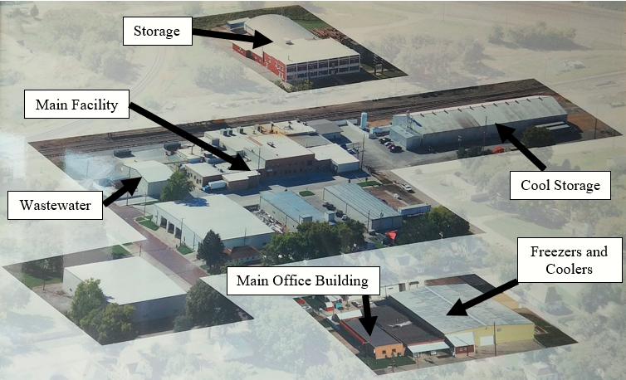

Topper Building

**Figure 3-1:** Major Buildings Comprising Westin

The main office building is located at 602 Bacon Road in Fairbury. This is about two blocks to the west of the main operating facility, at 802/810 Bacon Road. Figure 3-2 shows an aerial view of the two buildings to distinguish location. Figure 3-3 shows an aerial view of the main operating facility.

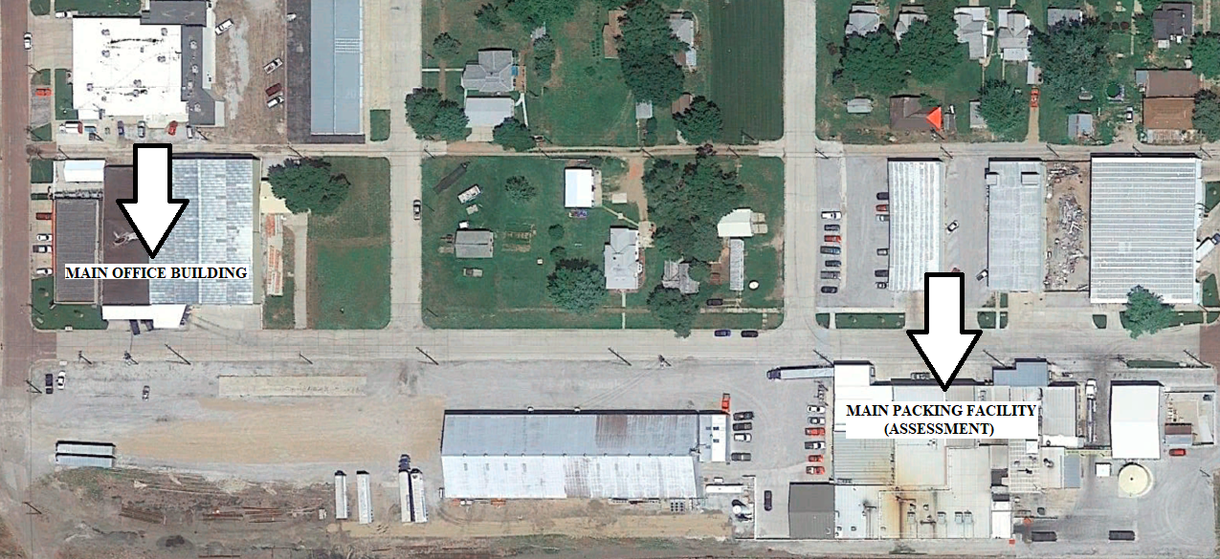

Main Operating Facility

(Assessment)

Main Office Building

(Check-in)

**Figure 3-2:** Aerial Layout of Office and Main Operating Facility

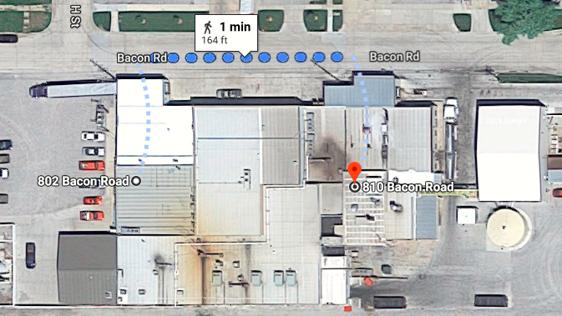

**Figure 3-3:** Aerial View of Main Operating Facility

Figure 3-4 shows a sideways plan view of the main operating facility layout. The Nebraska Industrial Assessment Center (NIAC) team installed two FUJI Ultrasonic Flowmeters to monitor daily water use. The installation locations are detailed in this figure, along with major processing areas.

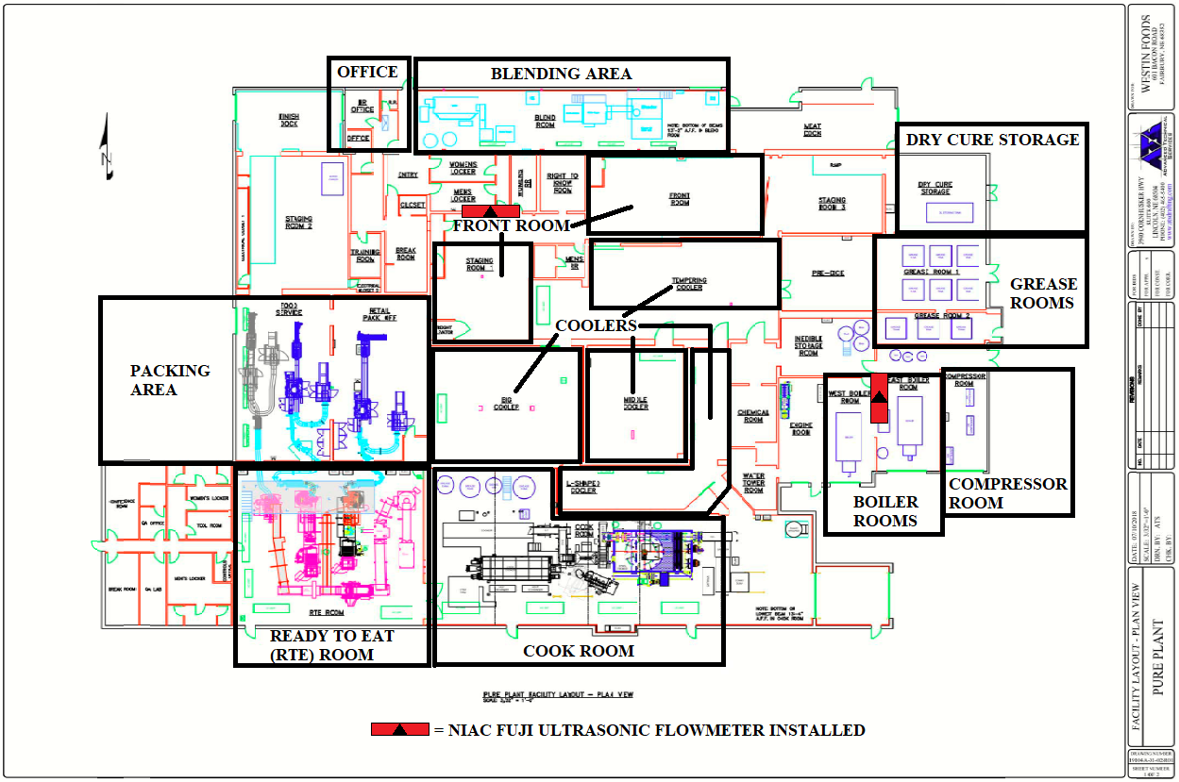

**NORTH >>>**

**Figure 3-4:** Main Operating Facility Layout – Detailed Plan View

## 3.2 General Process Description

The main process for packaging meat at Westin Packaged Meats’ main operating facility is detailed in Figure 3-5 below. Consisting of five major steps, meat begins in the dry curing process and ends either packaged for retail or foodservice.

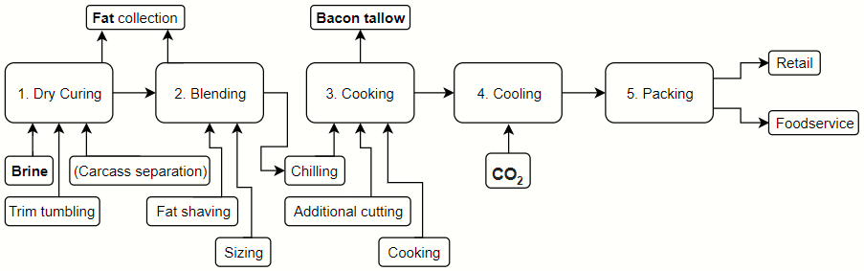

**Figure 3-5:** General Process Flow Diagram

The first step in the process is dry curing, which involves separating carcasses into fat or trim. Here, trim is tumbled, and brine is added to the mixture. Unused material is stored in the Dry Cure Storage area (Figure 3-4). Next, the different raw materials are blended in the blending room to specific consistencies and the material is chilled before the cooking process. The chilled material is moved to the cook room where it is frozen, cut, and cooked. Process grease (bacon tallow) is collected during the cooking process and stored in the Grease Rooms (Figure 3-4) to be used for boiler fuel for approximately 5 days per week. After the cooking process, material is sent to the big, middle, tempering, and L-shaped coolers. CO2 is currently used to power these coolers, but Westin Packaged Meats plans to switch to a mechanical cooling tower powered by frion. Finally, material is sent to the Ready to Eat (RTE) Room, where it is resized for packing. The material moves on conveyors through the RTE Room into the Packing Area, where it is packaged for either retail or foodservice.

## 3.3 Utility Usage and Applications

The four utilities used at the facility are electricity, natural gas, water, and CO2. Westin Packaged Meats uses electricity to power the large majority of processing equipment, machinery, lighting, two boilers, and an air compressor. Natural gas is used to power their two boilers for approximately two days per week, when they run out of bacon grease tallow. They also use some natural gas for natural gas heaters throughout their facility. Water is used in many different areas of the production process but is primarily used for daily cleaning shifts, in which Westin uses approximately 31,200 gallons per shift. Carbon dioxide is used for coolers within the main facility and storage buildings.

## 3.4 Current Energy Efficiency and Waste Management Practices

Westin Packaged Meats currently practices several energy efficiency and waste management measures that minimize the plant’s environmental impact. Some of these include:

* Switching to mechanical (frion) cooling tower to reduce CO2 use by 50%
* Using variable frequency drive (VFD) on air compressor
* Reusing process grease (bacon tallow) as boiler fuel for 5/7 of workweek
* Utilizing LED lighting for 60% of main facility
* Using 3 Culligan high-efficiency water softeners within the steam process

## 3.5 Major Plant Equipment

Table 3-2 shows a summary of the major energy using units at Westin Packaged Meats. Note that this is not a comprehensive list, and some equipment may not have been identified. Motors with a small power usage and/or short operating time are excluded because they do not consume a significant amount of energy relative to other units at the facility. Some of the processing equipment is excluded due to relatively small power usage.

**Table 3-2:** Summary of Major Processing Equipment

|  |  |  |  |  |
| --- | --- | --- | --- | --- |
| **Location** | **Equipment/Application** | **Quantity** | **Total HP** | **Energy Capacity** |
| Compressor Room | Mattei Optima 90 460/6 Air Compressor Unit* | 1 | 120 | 120 psig |
| Cooker Room | East & West Lyco Motor & Disc  (40 hp each) | 2 | 80 | 30 kW each |
| Cooker Room | Bowl Chopper Motor | 1 | 400 | 298 kW |
| Cooker Room | Grinder Motor | 1 | 40 | 30 kW |
| Ready to Eat (RTE) Room | Centrifuge Motor | 1 | 20 | 15 kW |
| Blending Room | Blender Motors 1 & 2 (25 hp each) | 2 | 50 | 19 kW each |
| East and West Boiler Rooms | Hurst S1500-150-117/127 Boilers (300 hp each) | 2 | 600 | 150 psi max w.p. each |
| **Total** | | **10** | **1,310** |  |

*Equipped with a VFD

# 4.0 Utility Accounting

The four utilities used at Westin Packaged Meats are electricity, natural gas, water, and CO2. Based on bills provided by Westin Packaged Meats’ Operations Manager and the Fairbury Electricity Distributions Superintendent, Westin Packaged Meats spent **$1,358,484.75** on utilities for their main facility in 2018. Figure 4-1 details a breakdown of expenditures below.

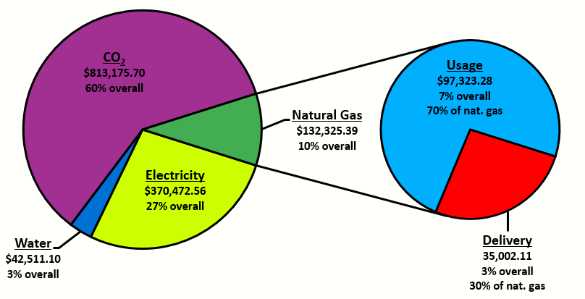

**Figure 4-1:** Westin 2018 Main Facility Utilities Summary

According to data from Google Maps (see Figure 4-2 below), the main packing facility shares two addresses: 810 Bacon Road and 802 Bacon Road. Because of this, all bills from Fairbury Light and Water for these two locations (including irrigation usage) were summated to generate 2018 utility data.



**Figure 4-2:** Westin Main Facility Addresses

## 4.1 Electricity Analysis

Table 4-1 below details electrical utility data for the 2018 year. Fairbury Light and Water meters Westin Meat’s electrical demand in 15-minute intervals. The average demand rate calculated for Westin Meats was found to be **$15.80/kW**, and the average usage rate was found to be **$0.0404/kWh**. These rates were calculated from 2018 electrical bills provided by Fairbury Light and Water. According to the Fairbury Utilities Electric Distribution Superintendent, Fairbury Light and Water offers two kinds of discounts to manufacturers. The first is a 1.5% discount on any facility that uses primary metering, which is applied to the bills for Westin Meats. The second is a 2% discount for manufacturers owning their own transformers but does not apply to Westin Packaged Meats.

**Table 4-1:** Summary of 2018 Electric Bills

|  |  |  |  |  |  |  |
| --- | --- | --- | --- | --- | --- | --- |
| **2018 Month** | **Usage (kWh)** | **Demand (kW)** | **Usage Charge** | **Demand Charge** | **Fees** | **Total Bill** |
| January | 346,200 | 751.8 | $16,498.97 | $10,901.10 | $25 | $27,425.07 |
| February | 350,400 | 763.2 | $16,696.09 | $11,066.40 | $25 | $27,787.49 |
| March | 327,000 | 717.6 | $15,597.81 | $10,405.20 | $25 | $26,028.01 |
| April | 315,600 | 745.2 | $15,062.75 | $10,805.40 | 0 | $25,868.15 |
| May | 373,200 | 859.8 | $18,869.02 | $15,476.90 | $25 | $34,370.42 |
| June | 444,000 | 943.2 | $22,401.25 | $16,977.60 | $25 | $39,403.85 |
| July | 375,600 | 878.4 | $18,988.76 | $15,811.20 | $25 | $34,824.96 |
| August | 415,800 | 890.4 | $20,994.35 | $16,027.20 | $25 | $37,046.55 |
| September | 430,800 | 912 | $20,469.68 | $13,224.00 | $25 | $33,718.68 |
| October | 351,600 | 870 | $17,358.50 | $13,084.80 | $25 | $30,468.30 |
| November | 321,000 | 729 | $15,869.54 | $10,964.16 | $25 | $26,858.70 |
| December | 327,000 | 697.2 | $16,161.49 | $10,485.89 | $25 | $26,672.38 |
| **Totals:** | **4,378,200** | **Avg: 813.5** | **$214,968.21** | **$155,229.35** | **$275** | **$370,472.56** |

Table 4-2 details the calculated usage and demand rates, days within each billing period, and load factor data. Electrical load factors measure the efficiency of electrical usage within a facility and are calculated as the ratio of total energy used within a billing period divided by the possible total energy used during that period. A load factor of above 75% is reasonably efficient, while a load factor of below 50% signifies period of high demand with low utilization. Electrical Load factor can be calculated using this formula:

$$Electrical Load Factor=\frac{Monthly Usage}{Peak Monthly Demand}÷\frac{Days in Monthly Billing Cycle}{24 Hours per Day}*100\%$$

**Table 4-2:** Westin 2018 Electrical Load and Period Data

|  |  |  |  |  |  |  |
| --- | --- | --- | --- | --- | --- | --- |
| **2018 Month** | **Start Date** | **End Date** | **Number of Days in Period** | **Electrical Load Factor** | **Usage Rate ($/kWh)** | **Demand Rate ($/kW)** |
| January | 1/5/2018 | 2/7/2018 | 29 | 66.16% | 0.04766 | 14.50 |
| February | 2/7/2018 | 3/9/2018 | 30 | 63.77% | 0.04765 | 14.50 |
| March | 3/9/2018 | 4/6/2018 | 31 | 61.25% | 0.04770 | 14.50 |
| April | 4/6/2018 | 5/4/2018 | 29 | 60.85% | 0.04770 | 14.50 |
| May | 5/4/2018 | 6/11/2018 | 30 | 60.29% | 0.04147 | 18.00 |
| June | 6/11/2018 | 7/9/2018 | 32 | 61.29% | 0.03824 | 18.00 |
| July | 7/9/2018 | 8/7/2018 | 28 | 63.63% | 0.04210 | 18.00 |
| August | 8/7/2018 | 9/10/2018 | 30 | 64.86% | 0.03855 | 18.00 |
| September | 9/10/2018 | 10/8/2018 | 33 | 59.64% | 0.03070 | 14.50 |
| October | 10/8/2018 | 11/14/2018 | 30 | 56.13% | 0.03722 | 15.04 |
| November | 11/14/2018 | 12/10/2018 | 29 | 63.27% | 0.03416 | 15.04 |
| December | 12/10/2018 | 1/8/2019 | 32 | 61.07% | 0.03207 | 15.04 |
|  |  | **Totals:** | **363 days** | **Avg: 61.85%** | **Avg: $0.0404/kWh** | **Avg: $15.80/kW** |

Table 4-3 compares Westin Packaged Meats’ electrical demand for their entire property to demand in the main operating facility during the month of April in 2019. Fairbury Light and Water meters Westin Meat’s electrical demand in 15-minute intervals.

**Table 4-3:** Westin April 2019 Electrical Demand and Period Data

|  |  |  |  |  |  |
| --- | --- | --- | --- | --- | --- |
| **Location** | **Start Date** | **End Date** | **Number of Days in April Period** | **Demand (kW)** | **Demand Cost** |
| Main Facility | 4/9/2019 | 5/7/2019 | 29 | 790 | $11,885 |
| All Property | 4/9/2019 | 5/7/2019 | 29 | 1,260 | Estimated $18,950 |

Figure 4-3 details the day-to-day variation in Westin Packaged Meats’ electrical demand for their entire property during the month of April in 2019, to illustrate the difference between the entire property demand and the main operating facility’s demand. The entire property achieved a peak demand of 1,260 kW on Wednesday, April 24th, 2019.

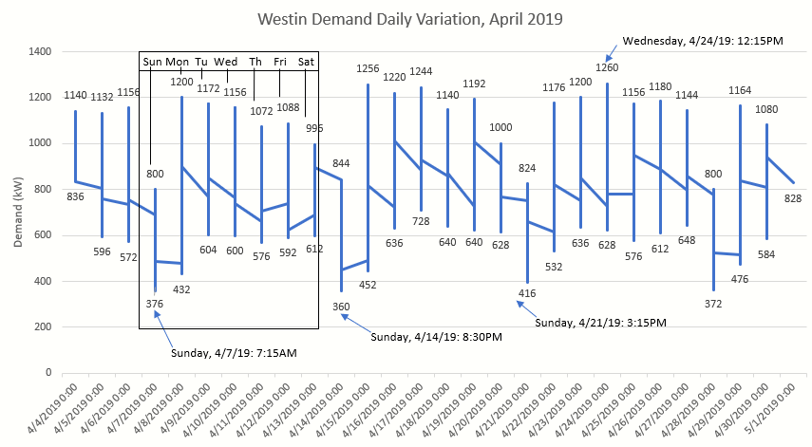

**Figure 4-3:** Westin Entire Property Demand, April 2019

Figure 4-4 compares Westin’s electrical usage and demand during 2018. The electric load factor is also shown to highlight the semi-proportional relation between the difference in usage and demand and the load factor value for the month. As we can see in these figures, Westin’s demand on Sundays is significantly lower than its demand on the first 3 days of the workweek. This is due to Westin’s schedule: only cleaning and maintenance operates on Sunday. The average monthly electrical load factor for Westin was **61.85%**, which means there is moderate potential to lower Westin’s monthly demand charges.

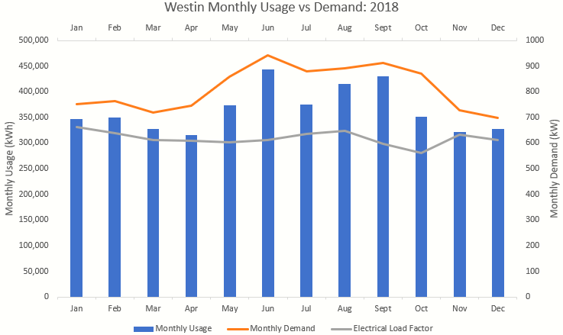

**Figure 4-4:** Westin 2018 Main Facility Monthly Usage vs. Demand

## 4.2 Natural Gas Analysis

As stated in Section 3.3, Westin Packaged Meats uses natural gas to power their two boilers and handful of natural gas heaters. Westin currently purchases their natural gas from Constellation NewEnergy (CNE), utilizing Black Hills Energy (BHE) delivery. Black Hills charges Westin a franchise fee of 5% for each monthly bill. City sales tax for natural gas delivery is 2%, while state sales tax is 5.5%. In 2018, it cost Westin **$0.09073 per therm** (100,000BTU or 0.10 million metric BTU [MMBTU]) for utilizing the Black Hills Energy delivery system. Westin is also charged a customer charge of $242.00 per month from Black Hills, totaling $2,904 per year. Natural gas is priced at **$0.315/therm**, or $3.15/MMBTU. Table 4-4 details natural gas data for the 2018 year.

**Table 4-4:** Summary of Westin 2018 Natural Gas Utility Data

|  |  |  |  |  |  |  |  |  |
| --- | --- | --- | --- | --- | --- | --- | --- | --- |
| **2018**  **Month** | **Therms** | **Delivery Cost** | **Franchise Fee** | **City Sales Tax** | **State Sales Tax** | **BHE Total Bill** | **CNE Total Bill** | **Overall Cost** |
| Jan | 24,716 | $2,242.48 | $124.22 | $52.17 | $143.48 | $2,804.35 | $3,366.78 | $10,589.89 |
| Feb | 28,147 | $2,553.78 | $139.79 | $58.71 | $161.46 | $3,155.74 | $3,466.44 | $12,022.04 |
| Mar | 28,113 | $2,550.69 | $139.63 | $58.65 | $161.28 | $3,152.25 | $3,382.54 | $12,007.85 |
| Apr | 31,605 | $2,867.52 | $155.48 | $65.30 | $179.58 | $3,509.88 | $3,403.77 | $13,465.46 |
| May | 27,656 | $2,509.23 | $137.56 | $57.78 | $158.88 | $3,105.45 | $3,443.10 | $11,817.09 |
| Jun | 25,843 | $2,344.74 | $129.34 | $54.32 | $149.36 | $2,919.78 | $3,791.00 | $11,060.33 |
| Jul | 20,777 | $1,885.10 | $106.36 | $44.67 | $122.84 | $2,400.97 | $3,327.81 | $8,945.73 |
| Aug | 22,493 | $2,040.79 | $114.14 | $47.94 | $131.83 | $2,576.70 | $3,900.55 | $9,662.00 |
| Sept | 19,289 | $1,750.09 | $99.60 | $41.83 | $115.04 | $2,248.56 | $3,913.99 | $8,324.60 |
| Oct | 23,338 | $2,117.46 | $117.97 | $49.55 | 136.26 | $2,663.24 | $3,696.80 | $10,014.71 |
| Nov | 25,493 | $2,312.98 | $127.75 | 53.65 | $147.55 | $2,883.93 | $3,261.41 | $10,659.30 |
| Dec | 32,302 | $2,930.76 | $158.64 | $ 66.63 | $183.23 | $3,581.26 | $3,556.91 | $13,756.39 |
| **Totals:** | **309,772** | **$28,105.62** | **$1,550.48** | **$651.20** | **$1,790.79** | **$2,966.25** | **$42,511.10** | **$132,325.39** |

The degree days system is a measurement system describing the measurement of temperature difference from a setpoint (usually 65° F). Heating degree days (HDD) measure how cold the temperature was for a given amount of days. In this case, HDD are based on the 65° F setpoint. A high number of degree days generally results in higher levels of natural gas use for space heating.[1] For an example, if the mean temperature for a certain day is 40° F, that day has 25HDD if the setpoint used is 65° F. Information from the KBIE Weather Station at the Beatrice Municipal Airport in Nebraska is the closest weather station to Westin Packaged Meats, so HDD data was used from this station for this report.

**Table 4-5:** Westin 2018 Monthly Heating Degree Days

|  |  |  |  |  |  |  |  |  |  |  |  |  |
| --- | --- | --- | --- | --- | --- | --- | --- | --- | --- | --- | --- | --- |
| **Month:** | **Jan** | **Feb** | **Mar** | **Apr** | **May** | **Jun** | **Jul** | **Aug** | **Sept** | **Oct** | **Nov** | **Dec** |
| **HDD:** | 1,226 | 1,064 | 710 | 608 | 54 | 5 | 4 | 11 | 90 | 432 | 911 | 1,019 |

Figure 4-5 shows natural gas usage (excluding delivery) for the 2018 year. Monthly HDD data is plotted against natural gas usage to show which months required higher levels of natural gas. Once again, a high number of heating degree days correlates to a higher number of cooler days, which require higher levels of natural gas use for the space heating application. Because natural gas usage is primarily fueling Westin Packaged Meats’ boilers two days per week, the natural gas usage graph is more dependent on production and cleaning use than space heating. This causes slight misalignments between the usage bar graph on the primary axis and the HDD line graph on the secondary axis.

**Figure 4-5:** Westin 2018 Natural Gas Usage and Monthly HDD

## 4.3 Water Analysis

Fairbury Light and Water supplies Westin’s water at approximately **$0.002/gal**. As stated in Section 3.3, water is used in many different areas of the production process but is primarily used for daily cleaning shifts, where Westin uses approximately 31,200 gallons per shift. As previously addressed, Google Maps shows the main packing facility sharing two addresses: 810 Bacon Road and 802 Bacon Road. For the months of 2018, 802 Bacon Road was sent 3 bills per month and 810 Bacon Road was sent 2 bills per month (1 for facility and 1 for irrigation). For the most accurate representation of usage in the main facility, all water bills from Fairbury Light and Water for these two locations (including irrigation usage) were used to generate 2018 water utility data. Table 4-6 details the collection of data from these five different bills for the 2018 year. Figure 4-6 shows the monthly water usage for the main packing facility.

**Table 4-6:** Summary of Westin 2018 Water Utility Data

|  |  |  |  |  |  |  |  |
| --- | --- | --- | --- | --- | --- | --- | --- |
| **2018**  **Month** | **Days within Period** | **Water Usage (CCF)** | **Water Charge** | **Sewer Usage**  **(CCF)** | **Sewer Charge** | **Tax** | **Total Bill** |
| January | 29 | 1,422 | $ 1,838.55 | 1,422 | $ 1,293.34 | $ 234.89 | $ 3,366.78 |
| February | 30 | 1,526 | $ 1,910.44 | 1,526 | $ 1,314.16 | $ 241.84 | $ 3,466.44 |
| March | 31 | 1,629 | $ 1,922.71 | 1,629 | $ 1,223.84 | $ 235.99 | $ 3,382.54 |
| April | 29 | 1,534 | $ 1,796.28 | 1,534 | $ 1,270.01 | $ 237.48 | $ 3,403.77 |
| May | 29 | 1,516 | $ 1,925.94 | 1,495 | $ 1,276.94 | $ 240.52 | $ 3,443.10 |
| June | 33 | 1,639 | $ 2,115.91 | 1,565 | $ 1,410.57 | $ 264.52 | $ 3,791.00 |
| July | 28 | 1,386 | $ 1,834.60 | 1,352 | $ 1,261.03 | $ 232.18 | $ 3,327.81 |
| August | 30 | 1,631 | $ 2,135.05 | 1,591 | $ 1,493.34 | $ 272.16 | $ 3,900.55 |
| September | 33 | 1,726 | $ 2,150.98 | 1,663 | $ 1,489.96 | $ 237.05 | $ 3,913.99 |
| October | 30 | 1,604 | $ 2,010.47 | 1,601 | $ 1,428.42 | $ 257.91 | $ 3,696.80 |
| November | 28 | 1,408 | $ 1,797.56 | 1,404 | $ 1,236.32 | $ 227.53 | $ 3,261.41 |
| December | 33 | 1,596 | $ 1,969.81 | 1,596 | $ 1,338.92 | $ 248.18 | $ 3,556.91 |
|  | **Totals:** | **18,617** | **$ 23,408.30** | **18,378** | **$ 16,036.85** | **$ 2,966.25** | **$ 42,511.10** |

**Figure 4-6:** Westin 2018 Main Facility Water Usage

The NIAC team installed two FUJI Ultrasonic Flowmeters within the main operating facility to monitor daily water use in fifteen-minute intervals from Tuesday, July 9th, 2019 to Sunday, July 21st, 2019. One meter was installed on the main pipe in the Front Room and the other was installed in the East Boiler Room on the boiler feedwater valve. After completing logging on Wednesday, July 10th, an unknown source caused the sensors on the flowmeter in the Front Room to malfunction and duplicate the data logged after that point. However, enough data was logged to present a daily analysis of water flowing through that area that is representative of a typical production day. Figure 4-7 details this data. Figure 4-8 shows daily water use in the east boiler room for the same production day and Figure 4-9 shows water use for the East Boiler Room on a Sunday, when only cleaning and maintenance occurs.

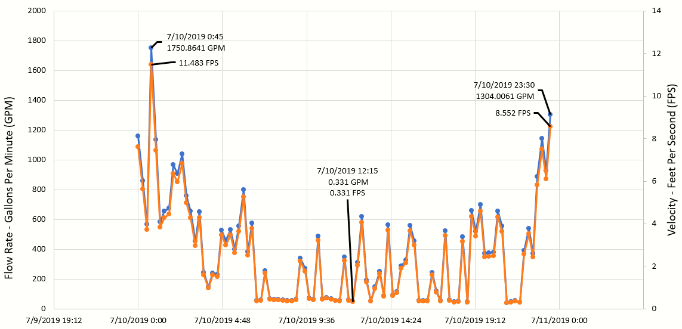

**Figure 4-7:** Front Room Meter Results: Wednesday, July 10th, 2019

Based on Figure 4-7, peak water use occurs around midnight when the cleaning shift begins after production ends. Figure 4-8 shows feedwater to the East Boiler Room for the same day. This follows a trend: weekday peak usage through the Front Room occurs at the beginning of cleaning shifts and variably decreases with local peaks during process use throughout the workday. In the East Boiler Room, usage varies during the midnight-to-five cleaning shifts and from 9:45am to midnight during production. From around 5:00am to 9:45am on production days, water flows at a rate of less than 0.5 gallons per minute (GPM).

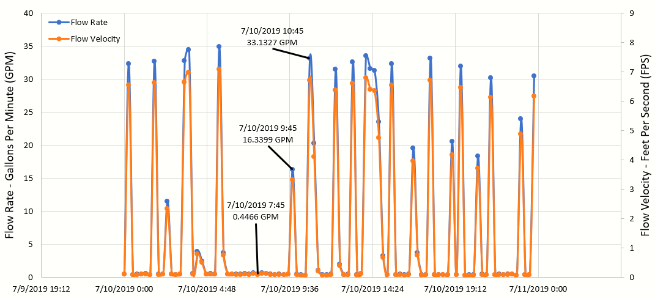

**Figure 4-8:** East Boiler Room Meter Results: Wednesday, July 10th, 2019

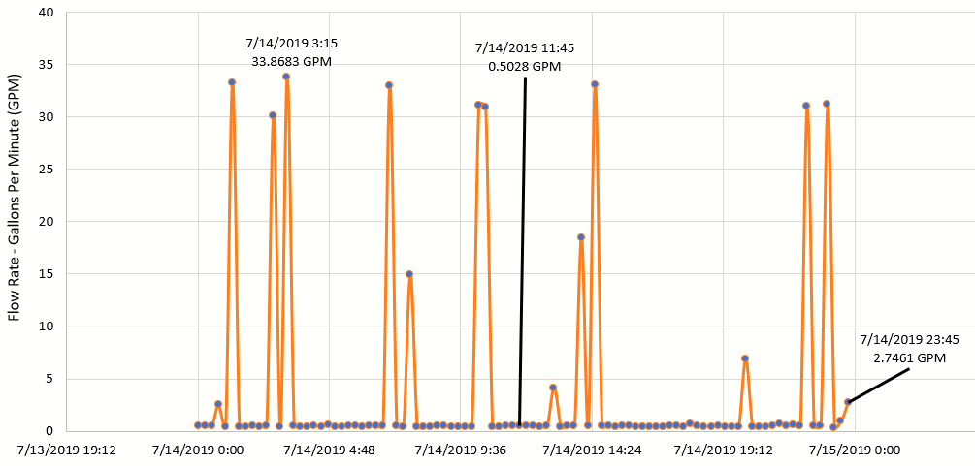

**Figure 4-9:** East Boiler Room Meter Results: Sunday, July 14th, 2019

Based on Figure 4-9, water use in the East Boiler Room during Sundays is sporadic – peaks occur a few times during the cleaning shift and vary throughout the maintenance shifts (after 9:45am). There are many hours during the day in which no water is being supplied to the East Boiler Room. However, the West Boiler Room could be responsible for supplying steam to the cleaning process and any maintenance processes requiring it during this period.

## 4.4 Carbon Dioxide Analysis

Westin purchases CO2 from Air Products for many of their cooling processes throughout their facility. Because CO2 purchasing receipts from Air Products are not specified by area of use, this summary includes all CO2 purchased by Westin Packaged Meats by shipment. CO2 is purchased at a rate of **$3.80 per 100lbs**. Table 4-7 details this data for 2018. Figure 4-10, provided by Air Products, details the amount of CO2 purchased by Westin per month.

**Table 4-7:** Summary of Westin 2018 CO2 Utility Data

|  |  |  |  |  |
| --- | --- | --- | --- | --- |
| **2018 Month** | **Quantity Purchased (lbs of** CO2**)** | **Number of Deliveries** | **Average Quantity per Delivery (lbs of** CO2**)** | **Total Bill** |
| January | 2,077,360 | 52 | 39,949.23 | $ 78,939.68 |
| February | 1,762,840 | 46 | 38,322.61 | $ 66,987.92 |
| March | 1,895,440 | 47 | 40,328.51 | $ 72,026.72 |
| April | 1,671,130 | 42 | 39,788.81 | $ 63,502.94 |
| May | 1,811,970 | 46 | 39,390.65 | $ 68,854.86 |
| June | 1,913,150 | 48 | 39,857.29 | $ 72,699.70 |
| July | 1,501,290 | 38 | 39,507.63 | $ 57,049.02 |
| August | 1,908,120 | 47 | 40,598.3 | $ 72,508.56 |
| September | 1,708,380 | 42 | 40,675.71 | $ 64,918.44 |
| October | 1,720,720 | 45 | 38,238.22 | $ 65,387.36 |
| November | 1,817,080 | 45 | 40,379.56 | $ 69,049.04 |
| December | 1,611,880 | 40 | 40,297.00 | $ 61,251.44 |
| **Totals:** | **21,399,360** | **538** | **477,333.5** | **$ 813,175.70** |

Westin CO2 usage is represented in Figure 4-10 in pounds of CO2. This figure was provided by Air Products, the CO2 supplier for Westin Packaged Meats.

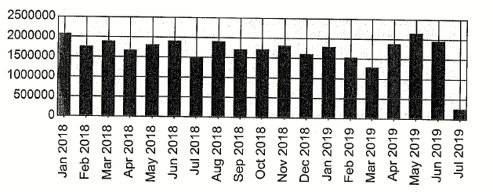

**Figure 4-10:** Westin 2018-to-Present CO2 Utility Usage

# 5.0 Energy Efficiency Assessment Recommendations

The following section describes the specific assessment recommendations provided for the facility. Each recommendation has some background information describing the recommendation, the estimated savings, implementation cost, and simple payback.

## 5.1 AR No. 1: Install Capacitor Bank to Improve Facility Power Factor

**Recommended Action**

It is recommended that Westin install a capacitor bank on the overhead bus in the substation to improve the facility’s power factor. By installing a capacitor bank, the facility can expect to see the savings displayed in Table 5.1-1. This power factor correction would meet or exceed the current standard of the Fairbury electric utility company.

**Table 5.1-1:** AR No. 1: Install Capacitor Bank to Improve Facility Power Factor Summary

|  |  |  |
| --- | --- | --- |
| **Annual Cost Savings** | **Implementation Cost** | **Simple**  **Payback**  **(years)** |
| $35,066 | $39,000 | 1.1 |

**Background**

Power factor is a measure of an electrical system’s efficiency. This measure of efficiency depends on the ratio of the real and reactive power that is consumed by a load. Real power, measured in kW, is the ‘useful’ power that does work, while reactive power, measured in kVAR, does no positive work. Reactive power is stored in the form of electric and magnetic fields that are generated during the operation of electrical equipment. Large inductive loads such as power transformers and motors are often the leading cause of poor power factor. Poor power factor mostly affects electric utility companies, causing them to implement additional demand charges on electric bills that are adjusted for poor power factor. A low power factor causes more reactive power to be drawn towards the system limiting the capacity of distribution lines to deliver useful energy to nearby facilities. Power factor may be improved by placing a bank of capacitors in parallel with a load. Capacitors produce a leading power factor that counteracts the lagging power factor created by inductive loads, ultimately increasing electrical efficiency.

Westin has an average power factor of 0.77. The facility’s power factor was measured on the day of the NIAC team’s assessment by a partnering electrician from Nebraska Municipal Power Pool (NMPP) and is shown in Appendix 6.1-A for illustrative purposes. NMPP provides power to the City of Fairbury utilities. Fairbury’s electric utility company charges facilities for inefficiencies that are below the community standard power factor. Although Westin currently does not get charged for their poor power factor, reactive power penalty charges may be implemented in the future.

**Anticipated Savings**

In coordination with NMPP, it is common practice for electric utility companies to implement power factor penalty charges for companies with power factors less than 0.95. The penalty charge is applied by scaling the monthly demand charge by a ratio of the facility’s average power factor and the standard power factor set by the electric provider. This equation is used to calculate the savings of future penalty charges as follows:

$$kW Demand* \frac{0.95}{pf}*MDR$$

Where,

$kW Demand=Average Monthly Demand \left(kW\right)$

$pf=Average Facility Power Factor$

$MDR=Monthly Demand Rate (\frac{\$}{kW*mon})$

Over the past year, Westin had an average monthly demand of 813.5 kW and a monthly demand rate of $15.80/kW. By substituting these values into the above equation, the annual savings on potential future power factor penalty charges can be estimated as follows:

$$813.5 kW* \frac{0.95}{0.77}* \frac{\$15.80}{kW*months}*12 months= \frac{\$190,295}{year}$$

This represents the total estimated cost of Westin’s demand charges and reactive power penalty charges over the past year. Subtracting Westin’s total demand charges of $155,229 from last year will yield the estimated reactive power penalty charges as follows:

$$\frac{\$190,295}{year}-\frac{\$155,229}{year}=\frac{\$35,066}{year}$$

**Implementation Cost and Simple Payback**

The cost of implementing the proposed capacitor bank consists of two components: material and labor. The NIAC’s partnering electrician’s power meter measured that 800 kVAR of reactive power must be improved in order to raise the facility’s power factor to 0.98. It is recommended that Westin achieve the 800 kVAR needed to improve the facility’s power factor by installing two 450 kVAR capacitor banks. A sales rep at WESCO sales estimated that a capacitor bank of this size would have a capital cost of $26,000 and labor costs of $13,000 to install the capacitor bank on the overhead bus in the substation. It is recommended that Westin coordinate a cost share with the City of Fairbury’s utilities company to help purchase the bank of capacitors.

Given this implementation cost and the anticipated cost savings, a simple payback period can be calculated as follows:

$$Payback Period=\frac{Implementation Cost}{Annual Cost Savings}$$

$$Payback Period=\frac{\$39,000}{\$35,066/year}= 1.1 years$$

**Additional Notes**

By improving the facility’s power factor, Westin will lessen the burden on electrical equipment within the facility, reduce voltage fluctuations and the risk of potential power surges, as well as help improve the City of Fairbury utility company’s relationship with regional power distributors.

## 5.2 AR No. 2: Implement A Steam Trap Maintenance Program

**Recommended Action**

It is recommended that Westin Packaged Meat implement a monthly steam maintenance program.

**Table 5.2-1:** AR No. 2: Implement a Steam Trap Maintenance Program Summary

|  |  |  |  |  |
| --- | --- | --- | --- | --- |
| **Solution** | **Annual Utility Savings** | **Annual Total Cost Saving** | **Implementation Cost** | **Simple Payback** |
| Implement a Steam Trap Maintenance Program | 15,697 MMBtu | $13,023 | $110 | 0.0 years |

**Background**

Westin Packaged Meats has a steam line through the cook room. The steam cooks the raw meat before it travels to the ready-to-eat room.

On the day of the assessment, there was a valve open on the steam valve because one of the steam traps was clogged. The cook room was refrigerated with a goal temperature of 50°F. Using a FLIR camera, the air surrounding the steam trap was approximately 240°F and noticeably heated the air more than ten feet from the valve (see Figure 5.2-1 and additional pictures in Appendix 6.2-A). According to the operations manager, the clogged steam traps are bypassed using open valves approximately two hours per day. By implementing a steam trap maintenance program, the clogs will be mitigated. By avoiding opening the steam valve, the cook room would save money from avoiding steam loss and lowering refrigeration demand.

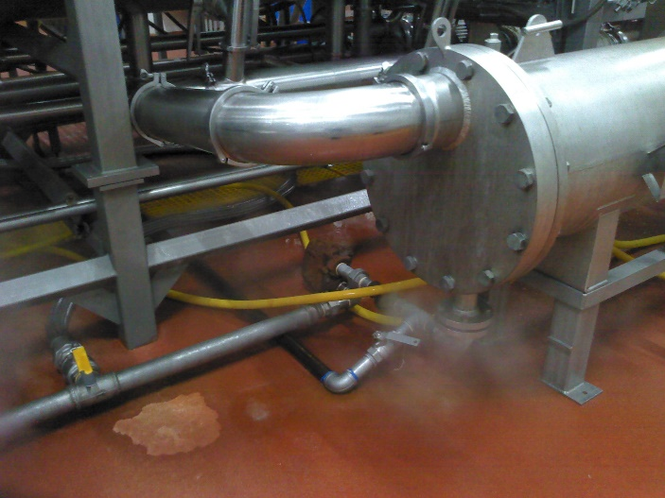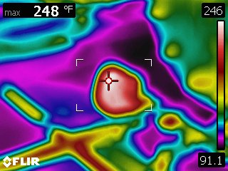

**Figure 5.2-1:** FLIR Thermal Image of Steam Trap Valve

**Anticipated Savings**

The valve opening is 1½” diameter and the steam line has a gauge pressure of 120 psi or an absolute pressure of 134.7 psi. The steam trap is replaced with an open valve for approximately ten minutes per hours for 14 hours per day, according to the operations manager. A variation of the Napier open orifice formula is used to calculate the rate of steam loss[2]. The following equation is used to calculate the estimate mass flow rate of steam leaving the valve:

$$W=k*P_{abs}*d_{o}^{2}$$

Where,

W = mass flow rate of steam leaving the valve (lb/hr)

k = correction factor from the Napier formula (unitless)

Pa = absolute pressure (psi)

do = diameter of orifice (in)

$$W=24.24*134.7p si*{\left(1.5 in\right)}^{2}=7,347 lb/hr$$

The energy lost annually is estimated using the following equation:

$$M=\frac{W*H*E*f}{e}$$

Where,

M = annual energy use of open steam valve (MMBtu/year)

H = time steam valve is open annually (hr)

E = latent heat of steam at 120 psi (Btu/lb)[3]

f = conversion factor (10-6 MMBtu/Btu)

e = boiler efficiency

$$M=\frac{2 valves*\frac{7,347 lb}{hr}*\left[\frac{10 min }{hr}*\frac{hr}{60 min}*\frac{14 hr}{day}*\frac{365 days}{year}\right]*\frac{878Btu}{lb}*\frac{{10}^{-6} MMBtu}{Btu}}{0.7}$$

$$M=15,697 MMBtu /year$$

Next, the cost of steam due to natural gas use is calculated. Bacon grease is used for 5/7 of all fuel use and natural gas is used as fuel for 2/7 of all fuel use. The cost of steam lost annual is calculated using the following equation:

$$C=M*r*p$$

Where,

C = annual cost of steam ($/year)

r = natural gas rate ($/MMBtu)

p = fraction of fuel use for natural gas (unitless)

$$C=\frac{15,697 MMBtu}{year}*\frac{\$3.15}{MMBtu}*2/7=\frac{\$14,127}{year}$$

The continual cost of manual labor by the maintenance team is calculated with the following equation:

$$L=R*h*n$$

Where,

L = annual cost of labor ($/year)

R = labor rate ($/hour)

h = time per inspection (hours)

n = inspections per year (/year)

$$L=\frac{\$23}{hour}*\frac{4 hours}{inspection}*\frac{12 inspections}{year}=\frac{\$1,104}{year}$$

The total anticipated annual cost savings is calculated using the following equation:

$$Annual Cost Savings=C-L$$

$$Annual Cost Savings=\frac{\$14,127}{year}-\frac{\$1,104}{year}=\frac{\$13,023}{year}$$

**Implementation Cost and Simple Payback**

Implementation cost is considered to be two hours of administrative tasks to plan the monthly maintenance program and instruct maintenance workers regarding the new tasks.

$$Implementation Cost=R*h$$

$$Implementation cost=\frac{\$22}{hour}*5 hours=\$110$$

$$Payback Period=\frac{Implementation Cost}{Annual Cost Savings}$$

$$Payback Period=\frac{\$110}{\frac{\$13,023}{year}}=0.0 years \sim 3 days$$

**Additional Notes**

There are additional savings due to decreased refrigeration demand that are difficult to accurately calculate. The steam released from the open valve on the steam line increases the temperature of the cook room significantly. With the implementation of a steam maintenance program, the steam valves will remain closed, resulting in lower costs due to refrigeration.

## 5.3 AR No. 3: Upgrade Facility Lighting

**Recommended Action**

It is recommended that Westin Packaged Meats upgrade their current lighting throughout the facility. The area evaluated for the purposes of this recommendation is comprised of four main areas: the main operating facility and RRC, the warehouses, the topper building, and the west plant. These four areas currently use 5 different types of non-LED lights including 4-ft and 8-ft T-8 fluorescent light bulbs, indoor and outdoor (night light) halogen bulbs, and metal halide lights with various numbers of bulbs per fixture depending on the area within the facility. By replacing these bulbs with similar LED bulbs, it can be expected to see savings as detailed in Table 5.3-1.

**Table 5.3-1:** AR No. 3: Upgrade Facility Lighting Summary

|  |  |  |  |  |
| --- | --- | --- | --- | --- |
| **Annual Energy Savings** | **Monthly Demand Savings** | **Annual Cost Savings** | **Implementation Cost** | **Simple**  **Payback** |
| 175,543 kWh | 29 kW | $12,538 | $7,282 | 0.6 years |

**Background**

Westin Packaged Meats has 642 Non-LED light bulbs throughout the four different sections of the main operating facility and RRC, warehouses, topper building, and west plant. The electricity for these sections is supplied through 4 electricity meters. There are 5 different types of bulbs: 4-ft and 8-ft T-8 fluorescent light bulbs, indoor and outdoor (night light) halogen bulbs, and metal halide lights. The 318 fixtures related to these bulbs contain 1-2 bulbs per fixture depending on the location within the facility. It is also worth noting that at the time of this report, more than 60% of the lighting system inside the whole facility is already upgraded to LED. Table 5-3.2 contains the number of lighting fixtures as well as the number of bulbs per fixture used in our calculations.

Light Emitting Diode (LED) lighting solutions have been available since the year 2000 but have only recently become widespread in most applications. This is largely due to the improvement of the technology as well as their drop-in price. Since 2008, LED lighting costs have dropped more than 85%[4]. LEDs have the benefit of being both an energy efficient technology as well as having superior lighting quality compared to fluorescent or HID technologies. Typical lamp life of LEDs is also considerably longer than other lighting technologies.

Many modern LED lighting solutions are simple to choose and install, often requiring no retrofit. These drop-in solutions are often more inexpensive than getting a new retrofit fixture; however, they often do not meet the particular needs of a company. For best results, it is always suggested that a professional lighting audit be performed to assist you in choosing the best lighting solution for your facility. In this report, the quotes were provided by online vendors. These may not be the best match for your facility, but they are accurate enough to give you a budgetary estimate of replacement cost and energy savings you can expect with a lighting conversion.

**Anticipated Savings**

The energy and cost savings analysis in this report compares the current lighting with the proposed upgrade lighting through the implementation of LEDs. The wattages of the LED replacements were estimated by comparing products recommended by NIAC partners to products researched online, and the projected annual energy usage was then calculated using these wattages. All calculations made during this comparison were made under the assumptions that there will be a 1-to-1 non-LED-to-LED replacement ratio and that the proposed lighting will have the same annual operating hours.

To find the anticipated savings for replacing the current lighting with LED lighting, the current cost of lighting must first be calculated. The energy, demand, and resulting cost of lighting can be calculated using the following equations:

$E_{Lighting}=N*W_{Bulb}*T$

$D_{Lighting}=N*W_{Bulb}$

$C_{Lighting}={(E}_{Lighting}*UC)+{(D}_{Lighting}*DC*M)$

where,

ELighting = Annual Energy Usage (kWh/year)

DLighting = Electrical Demand (kW)

N = Number of Lamps

WBulb = Wattage of Lamp (kW)

T = Time in Operation (hours/year)

UC = Usage Rate ($/kWh)

DC = Monthly Demand Rate ($/kW-month)

M = Months in Operation (months/year)

CLighting = Annual Lighting Cost ($/year)

Substituting values for the main plant section 4-ft T-8 fluorescent light bulbs will yield the following Annual Energy Usage and Electrical Demand:

$$E_{Lighting}=105 * 0.032 kW* \frac{7,900 hours}{year}$$

$$E_{Lighting}=\frac{26,544 kWh}{year}$$

$$D_{Lighting}= 105 * 0.032 kW$$

$$D_{Lighting}= 3.4 kW$$

The Annual Lighting Cost for the current lighting scheme is calculated as follows:

$$C_{Lighting}=\left(\frac{26,544 kWh}{year}*\frac{\$0.0404}{kWh}\right)+\left(3.4 kW*\frac{\$15.8}{kW*month}* \frac{12months}{year}\right)$$

$$C_{Lighting}=\frac{\$1,709}{year}$$

Note that these values calculated above are an example calculation for the main plant. Table 5.3-2 lists the current lighting specifications and operating conditions for current Non-LED lights. The number of bulbs seen in the table and used in calculations are based on the data the NIAC team collected while at the facility. The fixture wattage and annual operation time are calculated based on the information received from facility staff. Westin is assumed to operate 7,900 hours for the main operating facility and buildings, 50% of this time (3,950 hours) for night lights, and one third of this time (2,633 hours) for warehouses. Table 5.3-3 lists the proposed lighting specifications and operating conditions for the recommended LED fixtures. These tables are broken down by area in the facility.

**Table 5.3-2:** Summary of Current Fluorescent Lighting

|  |  |  |  |  |  |  |  |
| --- | --- | --- | --- | --- | --- | --- | --- |
| **Area** | Light Type | Bulb Wattage (W) | Total # of Bulbs | Demand (kW/month) | Opt. Hours (h/year) | Energy Usage (kWh/year) | Annual Cost ($/year) |
| Main Plant and RRC | T8 4-ft | 32 | 105 | 3.4 | 7,900 | 26,544 | 1,709 |
| T8 8-ft | 86 | 94 | 8.1 | 7,900 | 63,864 | 4,113 |
| Halogen Night light | 150 | 2 | 0.3 | 3,950 | 1,185 | 105 |
| Halogen indoor | - | 0 | 0.0 | 7,900 | 0 | 0 |
| Metal Halide | 400 | 9 | 3.6 | 7,900 | 28,440 | 1,832 |
| Warehouses | T8 4-ft | 32 | 32 | 1.0 | 2,633 | 2,697 | 303 |
| T8 8-ft | 86 | 30 | 2.6 | 2,633 | 6,794 | 764 |
| Halogen Night light | 150 | 2 | 0.3 | 3,950 | 1,185 | 105 |
| Halogen indoor | 100 | 5 | 0.5 | 2,633 | 1,317 | 148 |
| Metal Halide | 400 | 18 | 7.2 | 2,633 | 18,960 | 2,131 |
| Topper building | T8 4-ft | 32 | 54 | 1.7 | 7,900 | 13,651 | 879 |
| T8 8-ft | 86 | 20 | 1.7 | 7,900 | 13,588 | 875 |
| Halogen Night light | 150 | 1 | 0.2 | 3,950 | 593 | 52 |
| Halogen indoor | 100 | 5 | 0.5 | 7,900 | 3,950 | 254 |
| Metal Halide | 400 | 8 | 3.2 | 7,900 | 25,280 | 1,628 |
| West Plant | T8 4-ft | 32 | 212 | 6.8 | 7,900 | 53,594 | 3,451 |
| T8 8-ft | 86 | 12 | 1.0 | 7,900 | 8,153 | 525 |
| Halogen Night light | 150 | 11 | 1.7 | 3,950 | 6,518 | 576 |
| Halogen indoor | 100 | 22 | 2.2 | 7,900 | 17,380 | 1,119 |
| Metal Halide | - | 0 | 0.0 | 7,900 | 0 | 0 |
| **Total** | | | **642** | **46** |  | **293,690** | **20,570** |

**Table 5.3-3:** Summary of Proposed Lighting

|  |  |  |  |  |  |  |  |
| --- | --- | --- | --- | --- | --- | --- | --- |
| **Area** | Light Type | Bulb Wattage (W) | Total # of Bulbs | Demand (kW/month) | Opt. Hours (h/year) | Energy Usage (kWh/year) | Annual Cost ($/year) |
| Main Plant and RRC | T8 4-ft LED | 18 | 105 | 1.9 | 7,900 | 14,931 | 962 |
| T8 8-ft LED | 45 | 94 | 4.2 | 7,900 | 33,417 | 2,152 |
| LED Night light | 23 | 2 | 0.0 | 3,950 | 182 | 16 |
| LED indoor | 14 | 0 | 0.0 | 7,900 | 0 | 0 |
| LED (halide Equal) | 60 | 9 | 0.5 | 7,900 | 4,266 | 275 |
| Warehouses | T8 4-ft | 18 | 32 | 0.6 | 2,633 | 1,517 | 170 |
| T8 8-ft | 45 | 30 | 1.4 | 2,633 | 3,555 | 400 |
| Halogen Night light | 23 | 2 | 0.0 | 3,950 | 182 | 16 |
| Halogen indoor | 14 | 5 | 0.1 | 2,633 | 184 | 21 |
| LED (halide Equal) | 60 | 18 | 1.1 | 2,633 | 2,844 | 320 |
| Topper building | T8 4-ft | 18 | 54 | 1.0 | 7,900 | 7,679 | 495 |
| T8 8-ft | 45 | 20 | 0.9 | 7,900 | 7,110 | 458 |
| Halogen Night light | 23 | 1 | 0.0 | 3,950 | 91 | 8 |
| Halogen indoor | 14 | 5 | 0.1 | 7,900 | 553 | 36 |
| LED (halide Equal) | 60 | 8 | 0.5 | 7,900 | 3,792 | 244 |
| West Plant | T8 4-ft | 18 | 212 | 3.8 | 7,900 | 30,146 | 1,941 |
| T8 8-ft | 45 | 12 | 0.5 | 7,900 | 4,266 | 275 |
| Halogen Night light | 23 | 11 | 0.3 | 3,950 | 999 | 88 |
| Halogen indoor | 14 | 22 | 0.3 | 7,900 | 2,433 | 157 |
| LED (halide Equal) | 60 | 0 | 0.0 | 7,900 | 0 | 0 |
| **Total** | | | **642** | **17** |  | **118,147** | **8,032** |

The anticipated savings for implementing the suggested lighting solution is the difference between these two values. A comparison of the two lighting configurations can be seen in Table 5.3-4.

**Table 5.3-4:** Comparison of Current Lighting and Proposed LED Lighting

|  |  |  |  |
| --- | --- | --- | --- |
| **Lighting Type** | **Energy Usage (kWh/year)** | **Demand (kW-month)** | **Total Annual Cost ($/year)** |
| Current | 293,690 | 46 | $20,570 |
| Proposed (LED) | 118,147 | 17 | $8,032 |
| **Savings** | **175,543** | **29** | **$12,538** |

**Implementation Cost and Simple Payback**

The cost of implementing the proposed lighting solution consists of two components: labor and material. Material cost is simply the lighting hardware. Labor cost reflects work done by either in-house maintenance and staff or professional installation by an external lighting company or electrician. According to the information provided during our post-assessment follow up, it requires an hour to work on 6 light bulbs (3 fixtures). A maintenance rate of $22 per hour was used assuming in-house staff would be used for the replacement. The NIAC recommends replacing current light bulbs with similar LED types, for which the cost is estimated in Table 5.3-5.

**Table 5.3-5:** Assumptions for Cost of Proposed LED Lighting

|  |  |  |
| --- | --- | --- |
| Light Type | Bulb Wattage (W) | Bulb Cost ($/bulb) |
| T8 4-ft LED | 18 | 5.8 |
| T8 8-ft LED | 45 | 10.6 |
| LED Night light | 23 | 9 |
| LED indoor | 14 | 4 |
| LED (halide Equal) | 60 | 19 |

As a result of these costs, an implementation cost can be determined with the following equations:

$$C_{Material}=N*C_{Lamp}$$

$$C_{Labor}=N*T*L_{Rate}$$

$$C_{Total}= C_{Material}+C_{Labor}$$

where,

CMaterial = Cost of Material ($)

CLabor = Cost of Labor ($)

CTotal = Total Implementation Cost ($)

N = Number of Lamps

CLamp = Lamp Cost ($/lamp)

T = Installation Time (hours/lamp)

LRate = Labor Rate ($/hour)

By substituting the known values, the total cost can be determined as described in Table 5.3-6.

**Table 5.3-6:** Implementation Cost of Proposed LED Lighting

|  |  |  |  |  |  |  |
| --- | --- | --- | --- | --- | --- | --- |
| **Area** | Light Type | Total # of Bulbs | Bulb Cost ($/bulb) | Total Bulb Cost ($) | Labor Cost ($) | Total Cost |
| Main Plant and RRC | T8 4-ft LED | 105 | 5.8 | 609 | 385 | 994 |
| T8 8-ft LED | 94 | 10.6 | 996 | 345 | 1,341 |
| LED Night light | 2 | 9 | 18 | 7 | 25 |
| LED indoor | 0 | 4 | 0 | 0 | 0 |
| LED (halide Equal) | 9 | 19 | 171 | 33 | 204 |
| Warehouses | T8 4-ft | 32 | 5.8 | 186 | 117 | 303 |
| T8 8-ft | 30 | 10.6 | 318 | 110 | 428 |
| Halogen Night light | 2 | 9 | 18 | 7 | 25 |
| Halogen indoor | 5 | 4 | 20 | 18 | 38 |
| LED (halide Equal) | 18 | 19 | 342 | 66 | 408 |
| Topper building | T8 4-ft | 54 | 5.8 | 313 | 198 | 511 |
| T8 8-ft | 20 | 10.6 | 212 | 73 | 285 |
| Halogen Night light | 1 | 9 | 9 | 4 | 13 |
| Halogen indoor | 5 | 4 | 20 | 18 | 38 |
| LED (halide Equal) | 8 | 19 | 152 | 29 | 181 |
| West Plant | T8 4-ft | 212 | 5.8 | 1,230 | 777 | 2,007 |
| T8 8-ft | 12 | 10.6 | 127 | 44 | 171 |
| Halogen Night light | 11 | 9 | 99 | 40 | 139 |
| Halogen indoor | 22 | 4 | 88 | 81 | 169 |
| LED (halide Equal) | 0 | 19 | 0 | 0 | 0 |
| **Total** |  | **642** |  | **4,928** | **2,354** | **7,282** |

Given this implementation cost and the anticipated cost savings, a simple payback period can be calculated as follows:

$$Payback Period=\frac{Implementation Cost}{Annual Cost Savings}$$

$$Payback Period=\frac{\$7,282}{\$12,538/year}= 0.58 years$$

Municipal Energy Agency of Nebraska (MEAN) provides lighting incentives through its commercial LED lighting program. When upgrading less efficient lighting product to new high-efficient lighting, a $2,500 per customer (separate account number for each service meter) per program rebate can be considered. The rebate year spans April 1st through March 31st. The procedure and limitation for this incentive program is described in their website[5] and Appendix 6.3-A.

Considering the MEAN lighting program incentives, all the implementation cost can be covered except the outdoor night lights, which are excluded from the program. Isolating the replacement of current night lighting with proposed LED night lighting will result in the following payback:

$$Payback Period=\frac{{Implementation Cost}_{night lights}}{{Annual Cost Savings}_{night lights}}=\frac{\$203}{\$710/year}= 0.29 years$$

**Additional Notes**

All products recommended to Westin Packaged Meats are based on student research, capital-only quotes from third-party vendors, and search observations. When implementing a more efficient lighting system, not every improvement that occurs as a result of implementation is quantifiable. Following a decrease in electrical consumption leads to a decrease in greenhouse gas emissions and a reduced carbon footprint. In addition to this, improved lighting can lead to improved worker morale, increasing the overall productivity of workers.

## 5.4 AR No. 4: Install Flow Restrictors in Cleaning Lines

**Recommended Action**

It is recommended that Westin install flow restrictors in the water lines used for cleaning operations. There are currently 13 cleaning stations throughout the facility. By installing these flow restrictors, Westin can expect to see savings as detailed in Table 5.4-1. These flow restrictors will reduce the water use during overnight cleaning operations while maintaining the necessary pressure needed to clean the facility’s equipment.

**Table 5.4-1:** AR No. 4: Install Flow Restrictors in Cleaning Lines Summary

|  |  |  |  |  |
| --- | --- | --- | --- | --- |
| **Annual Water Savings (gal/yr)** | **Annual Natural Gas Savings (MMBtu/yr)** | **Annual Cost Savings** | **Implementation Cost** | **Simple Payback (years)** |
| 2,730,000 | 716 | $7,716 | $1,127 | 0.2 |

**Background**

Westin currently has an external cleaning crew responsible for the overnight cleaning of company process equipment. Five-hour cleaning shifts take place seven days a week from midnight to 5:00am. Cleaning operations require a large amount of water usage. There are 13 cleaning stations throughout the facility that operate at a flow rate of 8 gallons per minute (GPM). To reduce the amount of water wasted during cleaning operations, it is recommended that Westin install flow restrictors that limit the water flow of the cleaning lines to a rate of 6 GPM. By restricting the flow rate of the cleaning lines by 2 GPM, Westin is expected to see considerable savings on water usage alone. The majority of the cost savings of installing flow restrictors will be due to the reduction of natural gas needed to heat the water used in cleaning lines. In order to clean process equipment, 55-degree municipal groundwater must be heated to 165 degrees. This requires a large amount of energy to achieve and is therefore expensive.

Westin currently uses recovered bacon tallow (process grease) as boiler fuel to heat the cleaning water, burning an average of 40 gallons per minute when in use. According to company representatives, on average, there is enough grease to heat the cleaning water for five days each week. Once the grease runs out, the cleaning water is heated by natural gas for the other two days. Since January of 2019 until July 15th, Westin Packaged Meats boilers have burned for 1,679 hours on grease. Based on this data, boilers run approximately 12 hours per day. Calculations for this estimate can be found in Appendix 6.4-B. By installing flow restrictors, the water wasted during cleaning operations will be significantly reduced resulting in savings for both water usage and heating.

**Anticipated Savings**

To find the anticipated savings for reducing the water wasted during overnight cleaning operations, the current cost of cleaning must first be calculated. The water, natural gas, and resulting cost of a cleaning shift can be calculated using the following equations:

$$W_{Usage }=N*FR*T$$

$$C_{Water }= W_{Usage }*WR$$

$$q=m*c_{p}*ΔT$$

$$C_{Natural Gas }= q*NGR$$

$$C_{Cleaning }=C_{Water}+ C_{Natural Gas}$$

Where,

$$W_{Usage }=Water Usage per Cleaning Shift (\frac{gal}{shift})$$

$$N=Number of Cleaning Stations$$

$$FR=Flow Rate (\frac{gal}{min})$$

$$T=Time of Cleaning Shift (hr)$$

$$C_{Water }= Cost of Water per Cleaning Shift (\$)$$

$$WR=Water Usage Rate (\frac{\$}{gal})$$

$$q=Natural Gas Usage per Cleaning Shift (\frac{therms}{shift})$$

$$m=Mass of water (gallons)$$

$$c_{p}=Specific Heat of Water=1.00 \frac{Btu}{lbm* ℉}=8.345 \frac{Btu}{gal* ℉}$$

$$ΔT=Change in Temperature (℉)$$

$$C_{Natural Gas }= Cost of Natural Gas per Cleaning Shift (\$)$$

$$NGR=Natural Gas Usage Rate=\frac{\$3.15}{MMBtu}$$

$$C_{Cleaning }= Cost of Cleaning Shift using natural gas (\$)$$

Substituting values will yield the following result:

$$W_{Usage }=13 Stations* \frac{8 gal}{min} * \frac{5 hrs}{shift}* \frac{60 min}{hr}= \frac{31,200 gal}{shift}$$

$$C_{Water }= \frac{31,200 gal}{shift}* \frac{\$0.002}{gal}= \frac{\$62}{shift}$$

$$q=31,200 gal*8.345 \frac{Btu}{gal*℉}*\left(165℉-55℉\right)= \frac{28,640,040 Btu}{Shift} = \frac{28.64 MMBtu}{Shift}$$

$$C_{Natural Gas }= \frac{28.64 MMBtu}{shift}* \frac{\$3.15}{MMBtu}=\frac{\$90}{shift}$$

$$C_{Cleaning }=\$62+\$90=\frac{\$152}{shift}$$

In the above calculation, we assumed cp for water in this situation to be 1.00 Btu ÷ (lbm $℉)$* . Because each gallon of water in this situation weighs approximately 8.345 lbm, this constant can account for the conversion of gallons to pound mass (lbm). Using 8.345 Btu ÷ (gal $℉)$* in place of 1.00 Btu ÷ (lbm $℉)$* converts gallons of water to the Btus per degree Fahrenheit required to raise the mass of water by $ΔT$ degrees.

If Westin operates 50 weeks per year, it can be determined that there are approximately 350 cleaning shifts per year. Because natural gas is only used for two days per week, there are only 100 shifts per year in which natural gas is used. Table 5.4-2 shows the results of the current usage and costs of cleaning operations per shift and annually.

**Table 5.4-2:** Summary of Current Cleaning Operations

|  |  |  |  |  |  |
| --- | --- | --- | --- | --- | --- |
|  | **Water Usage (gal)** | **Water Usage Cost** | **Natural Gas Usage (MMBtu)** | **Natural Gas Usage Cost** | **Total Cost** |
| Cleaning Shift | 31,200 | $62 | 28.64 | $90 | $152 |
| Annual | 10,920,000 | $21,840 | 2,864 | $9,022 | **$30,862** |

Next, the cost of cleaning operations with the proposed flow restrictors is calculated. The same equations can be applied in the same way with a flow rate of 6 GPM to estimate the cost of the new cleaning operations.

$$W_{Usage }=13 Stations* \frac{6 gal}{min} * \frac{5 hrs}{shift}* \frac{60 min}{hr}= \frac{23,400 gal}{shift}$$

$$C_{Water }= \frac{23,400 gal}{shift}* \frac{\$0.002}{gal}= \frac{\$47}{shift}$$

$$q=23,400 gal*8.345 \frac{Btu}{gal*℉}*\left(165℉-55℉\right)= \frac{21,480,030 Btu}{Shift} = \frac{21.48 MMBtu}{Shift}$$

$$C_{Natural Gas }= \frac{21.48 MMBtu}{shift}* \frac{\$3.15}{MMBtu}=\frac{\$68}{shift}$$

$$C_{Cleaning }=\$47+\$68=\frac{\$115}{shift}$$

Once again, Table 5.4-3 shows the resulting cost per shift and annually. Keep in mind that when calculating annual data, these calculations apply to shifts in which natural gas is utilized.

**Table 5.4-3:** Summary of Proposed Cleaning Operations

|  |  |  |  |  |  |
| --- | --- | --- | --- | --- | --- |
|  | **Water Usage (gal)** | **Water Usage Cost** | **Natural Gas Usage (MMBtu)** | **Natural Gas Usage Cost** | **Total Cost** |
| Cleaning Shift | 23,400 | $47 | 21.48 | $68 | $115 |
| Annual | 8,190,000 | $16,380 | 2,148 | $6,766 | **$23,146** |

The anticipated savings for implementing the suggested flow restrictors is the difference between current cleaning costs and the cost of utilities to satisfy the proposed recommendation. A comparison of the two cleaning operations can be seen in Table 5.4-4. Note that these savings do not consider the cost of employing an exterior cleaning service, as it is assumed implementing this recommendation will not affect cleaning rates.

**Table 5.4-4:** Anticipated Savings of Proposed Flow Restrictors

|  |  |  |  |  |  |
| --- | --- | --- | --- | --- | --- |
|  | **Water Usage (gal)** | **Water Usage Cost** | **Natural Gas Usage (MMBtu)** | **Natural Gas Usage Cost** | **Total Savings** |
| Cleaning Shift | 7,800 | $15 | 7.16 | $23 | $38 |
| Annual | **2,730,000** | $5,460 | **716** | $2,256 | **$7,716** |

**Implementation Cost and Simple Payback**

The cost of implementing the proposed flow restrictors consists of two components: material and labor. Material cost is simply the cost of purchasing the required hardware. Labor covers the cost of the in-house maintenance staff to install the restrictors. The cost of a flow restrictor depends on its designated flow rate and not the dimensions of the pipe that it is installed on. VIQUA is one vendor that has a suitable 6 GPM flow restrictor. This flow restrictor costs $85 and is used in the calculations to follow. The installation of a flow restrictor is fairly simple, so it has been assumed that the cost of labor will be for in house maintenance at a rate of $22 per hour for one hour. Given these costs, an implementation cost can be determined with the following equations:

$$C_{Material}=N*C_{Restrictor}$$

$$C_{Labor}=T*L_{Rate}$$

$$C_{Total}= C_{Material}+C_{Labor}$$

where,

CMaterial = Cost of Material ($)

N = Number of Restrictors

CRestrictor = Cost of Flow Restrictor ($/restrictor)

CLabor = Cost of Labor ($)

T = Installation Time (hours)

LRate = Labor Rate ($/hour)

CTotal = Total Implementation Cost ($)

By substituting the known values, a total cost can be easily determined.

$$C_{Material}= 13 Restrictors *\frac{\$85}{Restrictor}=\$1,105$$

$$C_{Labor}=1 hour*\frac{\$22}{hour}=\$22$$

$$C_{Total}= \$1,105 + \$22$$

$$C_{Total}= \$1,127$$

Given this implementation cost and the anticipated cost savings, a simple payback period can be calculated as follows:

$$Payback Period=\frac{Implementation Cost}{Annual Cost Savings}$$

$$Payback Period=\frac{\$1,127}{\$7,716/year}= 0.15 years$$

## 5.5 AR No. 5: Repair Compressed Air Leaks

**Recommended Action**

It is recommended that Westin Packaged Meats’ implement a quarterly air leak detection and repair program in order to minimize air leaks within their air distribution system. In addition to the leak detection program, the identified air leaks should be repaired, and any air leaks discovered in the future should be tagged and repaired as they are found. Table 5.5-1 summarizes the potential savings and implementation costs associated with implementing this recommendation.

**Table 5.5-1:** AR No. 5: Compressed Air Leak Repair Summary

|  |  |  |  |
| --- | --- | --- | --- |
| **Annual Energy Savings (kWh/year)** | **Annual Cost Savings ($/year)** | **Implementation Cost ($)** | **Simple Payback (year)** |
| 126,284 | 4,921 | 1,600 | 0.3 |

**Background**

Westin currently has one 120 horsepower (HP) compressor providing compressed air to the main facility. The compressor is set at 120 psi and according to the compressor company, Mattei (see Appendix 6.5-A), the max compressor free air delivery is 557 cubic feet per minute (cfm). The compressor is run constantly and comprises a newer set-up where Westin replaced five 15 HP compressors with this larger unit two months ago. The compressor is operated with a variable frequency drive (VFD) and according to the readout on the equipment, the compressor runs loaded 65.3% of the time. The digital screen states the machinery has ran for 1628 hours and spent 1063 hours loading. It is assumed the current compressors are operating at 95.4% (see Appendix 6.5-A).

To supply all of its processes with compressed air, it costs Westin approximately 11% of their total electricity bill. Every compressed system will have leaks, but there is a target “acceptable” leakage range for different plant sizes[6]:

* For small plants the leakage should be from 5% to 7%.
* For medium plants the leakage should be from 7% to 10%.
* For large plants the leakage should be from 10% to 12%

A realistic goal for Westin should be a leakage rate of 7%.

To improve a plant’s leak performance, an air leak detection program can be implemented. A good leak prevention program should start with employee education and involvement. Employees should be taught the importance of compressed air, practices to avoid, such as open blowing for cleaning work areas, and how to identify and tag leaks they might find at or near their workstation. These tagged leaks should be reported to maintenance and repaired as soon as possible. In addition to ongoing employee involvement, a periodic check of the entire system for leaks using an ultrasonic leak detector is advised to find smaller leaks or leaks far away from employees. Since a poorly maintained compressed air system will degrade over time, new leaks will continually develop. By having a good leak detection and repair program it will be possible for Westin to maintain or surpass their leak rate goal.

During the assessment the IAC team performed a leak detection test with an ultrasonic leak detector. Over the course of one hour, the IAC team was able to identify 17 separate leaks when examining the packing area in the main facility. The measured sensitivity level (to the nearest tenth) varied from 8.8-7.3. Of these leaks, several were large enough to audibly hear and feel, indicating a large loss of air. There were also leaks that could be heard without the ultrasonic leak detector, which based off of the Department of Energy Compressed Air Leak Flowrates, Figure 5.1-2, accounts for a large percentage of lost air. A summary of the leaks can be found in Appendix 6.5-C, with the location of each leak provided in Appendix 6.5-B.

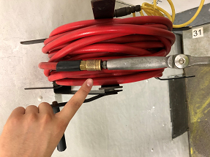

**Figure 5.5-1:** Picture of Nebraska Industrial Assessment Center Intern Identifying Leak

**Anticipated Savings**

To find the anticipated savings for repairing the identified leaks, the cost of the entire compressed air system must first be calculated. The cost of running a compressor can be calculated using the following equations[7].

where,

HP = Total Compressor Motor HP

ML = Motor Load

η = Compressor Efficiency

T = Time in Operation

UC = Usage Charge

L = Loading Factor

DC = Monthly Demand Charge

M = Months in Operation

The cost for the current compressor system can be calculated by adding the usage cost for the compressor running both loaded and unloaded to the demand cost for the compressor.

${Cost}_{Loaded}=\frac{\left(120 HP*1*0.746\frac{kW}{HP}*8,760\frac{hours}{year}*.0.653*\frac{\$0.0404}{kWh}\right)}{.954}$

${Cost}_{Loaded}=\frac{\$21,686}{year}$

${Cost}_{Demand}=\frac{\left(120 HP*1*0.746\frac{kW}{HP}*\frac{\$15.80}{kW-month}*12 month\right)}{0.954}$

${Cost}_{Demand}=\frac{\$17,791}{year}$

${Cost}_{Total}=\frac{\$21,686}{year}+\frac{\$17,791}{year}$

${Cost}_{Total}=\frac{\$39,477}{year}$

To determine the cost of air leaks, it is useful to calculate the cost of compressed air in the system. The total cost can be seen as a demand baseline with a usage cost that varies based on air use. To find the cost of air, the total usage cost can be divided by the air capacity of the system.

${Air}_{Cost}=\frac{{Cost}_{Loaded}}{Capacity}$

${Air}_{Cost}=\frac{\frac{\$21,686}{year}}{557 cfm}$

${Air}_{Cost}=\frac{\frac{\$39}{year}}{cfm}$

Annual energy as well as unit energy can be calculated in a similar fashion. The only modification to the original equation is the exclusion of the usage cost.

$Energy=\left(HP*ML*0.746\frac{kW}{hp}\right)*T*L/η$

${Energy}_{Loaded}=\frac{\left(120 HP*1*0.746\frac{kW}{HP}*8,760 \frac{hours}{year}*0.653\right)}{0.954}$

${Energy}_{Loaded}=\frac{536,771 kWh}{year}$

${Energy}_{Total}=\frac{536,771 kWh}{year}$

${Air}_{Energy}=\frac{{Energy}_{Total}}{Capacity}$

${Air}_{Energy}=\frac{536,771 \frac{kWh}{year}}{557 cfm}$

${Air}_{Energy}=\frac{\frac{964 kWh}{year}}{cfm}$

The Department of Energy (DOE) has classified the leakage rates of different sized diameters for audible, open air blowing holes (see Figure 5.5-2). During the assessment of Westin, the Nebraska Industrial Assessment Center observed five different leaks that were able to be heard from five feet away and felt upon further inspection. Based off of the standards provided by the DOE, see Figure 5.5-2, the assumptions designated for the orifice diameter and leakage rate of all holes found at Westin are provided in Appendix 6.5-C (see image 5, 14, 16, 17, and 19.). All leakage rates are rounded and have been interpolated to 120 pounds per square inch (psi) pressure for open air blowing.

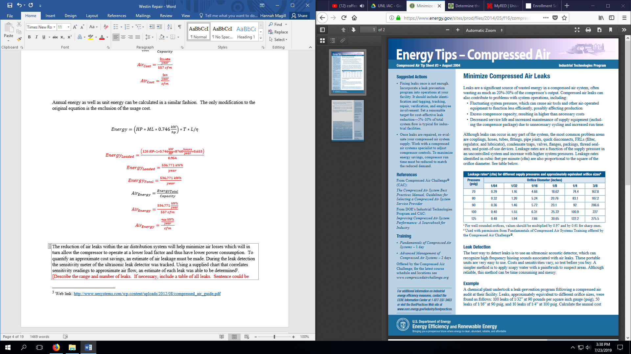

**Figure 5.5-2:** Volumetric Flowrates of Air Leaks Based off Orifice Diameter obtained from the U.S. Department of Energy[8]

To quantify an approximate cost savings, an estimate of air leakage must be made. During the leak detection the sensitivity meter of the ultrasonic leak detector was tracked. Using a supplied chart that correlates sensitivity readings to approximate air flow, an estimate of each leak was able to be determined[9]. The range of leaks included small leaks of 0.5 cfm, up to leaks that could be felt and heard unaided that were approximately 30 cfm. A total leakage rate of 106 cfm was found for the identified leaks. Because approximately 50% of the entire facility was scanned at Westin during the assessment, it is assumed that the entire facility will have a leakage rate of 131 cfm. The reduction of air leaks within the air distribution system will help minimize air losses which will in turn allow the compressor to operate at a lower load factor and thus have lower power consumption.

Given this air loss and the cost of air per cfm, the total cost and energy of the identified air leaks can be calculated.

${Savings}_{Cost}=Air Loss*{Air}_{Cost}$

${Savings}_{Cost}=131 cfm*\frac{\frac{\$39}{year}}{cfm}$

${Savings}_{Cost}=\frac{\$5,109}{year}$

${Savings}_{Energy}=Air Loss*{Air}_{Energy}$

${Savings}_{Energy}=131 cfm*\frac{\frac{964 kWh}{year}}{cfm}$

${Savings}_{Energy}=\frac{126,284 kWh}{year}$

This recommendation would only require the time and materials necessary to fix the identified leaks. A simple way to track these leaks is to use some kind of equipment repair tag. Depending on the quality and design desired, 50 of these can be purchased for as little as $10. Most air leaks occur at fittings and joints in pipes which can be tightened or replaced as necessary. A good thread sealant will improve the performance of these fittings and can be found at most online stores for prices between $10-$25. Accounting for the incidental costs and replacement fittings, it is assumed that materials for a leak detection program would cost approximately $100 per year.

Quarterly leak checks should be as thorough as is reasonably possible. Based on the experience of the IAC team during the assessment, a thorough check of the compressed air system with an ultrasonic leak detector could be completed in approximately 1 hours. It is assumed this check would be conducted by maintenance staff at a rate of $22/hour. The sum of equipment and labor costs required for the program will be the recurring costs of implementing a leak detection program.

${Cost}_{Program}=Equipment+Labor$

${Cost}_{Program}=\frac{\$100}{year}+\left(\frac{1 hours}{quarter}*\frac{4 quarters}{year}*\frac{\$22}{hour}\right)$

${Cost}_{Program}=\frac{\$188}{year}$

The overall savings of the program will be the savings due to the reduction of compressed air leaks minus the cost of running the program.

$Savings={Savings}_{Air}-{Cost}_{Program}$

$Savings=\frac{\$5,109}{year}-\frac{\$188}{year}$

$Savings=\frac{\$4,921}{year}$

**Implementation Cost and Simple Payback**

Costs of this recommendation depends on the level of leak detection that is implemented. At a minimum, this recommendation would require no capital investment, only the recurring time and material costs to repair discovered leaks. However, to get the most out of an air leak program, special equipment should be purchased to aid in identifying compressed air leaks. An ultrasonic leak detector is one of the best tools available for locating air leaks. Westin Packaged Meats should consider purchasing a leak detector to assist personnel during the quarterly leak checks. The price and functionality of ultrasonic leak detectors varies quite a bit. A simple model can be found for as little as $500, but a model similar to the one used by the IAC team during their assessment costs approximately $4,500. See Appendix 6.5-D for purchasing and descriptive information. For purposes of this assessment, a capital cost of $1,600 will be assumed. Given this implementation cost, a payback period can be calculated.

$Payback Period=\frac{Implementation Cost}{Annual Savings}$

$Payback Period=\frac{\$1,600}{\frac{\$4,921}{year}}$

$Payback Period=0.33 years$

# 6.0 Appendices

## 6.1 AR No. 1 Appendices

Appendix 6.1-A: Facility Power Factor Data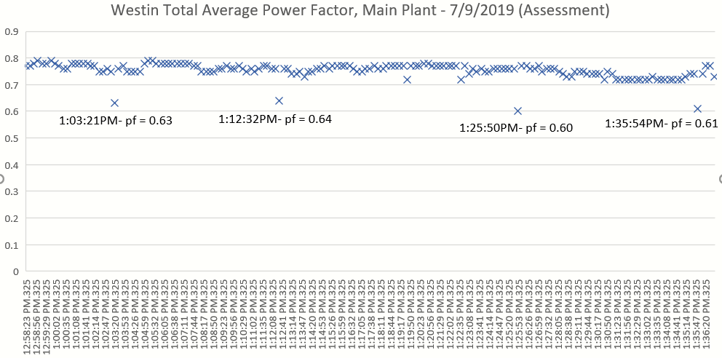

## 6.2 AR No. 2 Appendices

Appendix 6.2-A: Additional FLIR Thermal Images of Steam Trap Valve

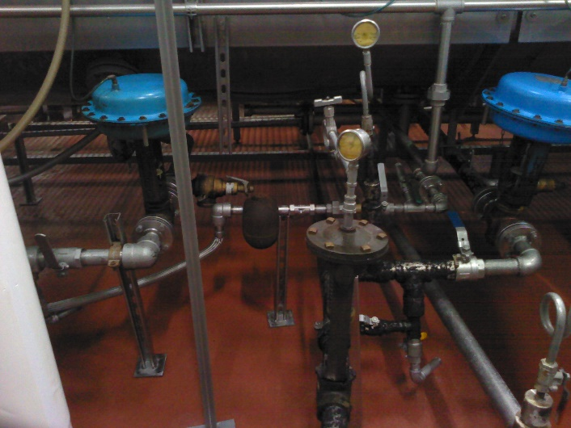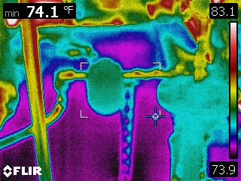

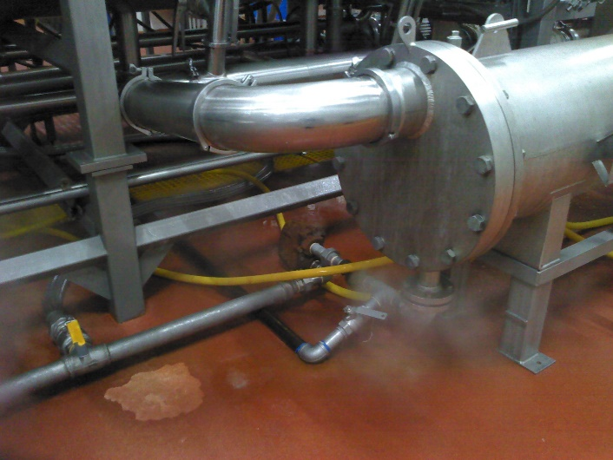

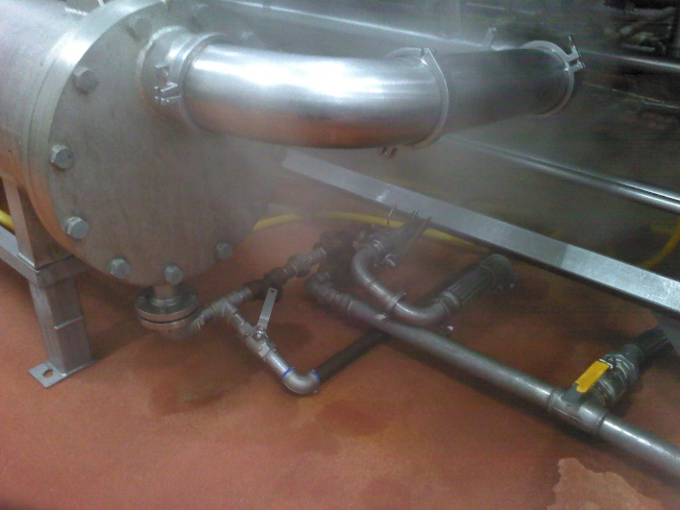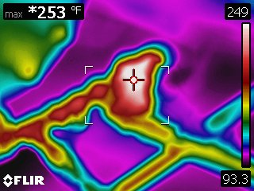

## 6.3 AR No. 3 Appendices

Appendix 6.3-A: MEAN Energy Efficiency Program

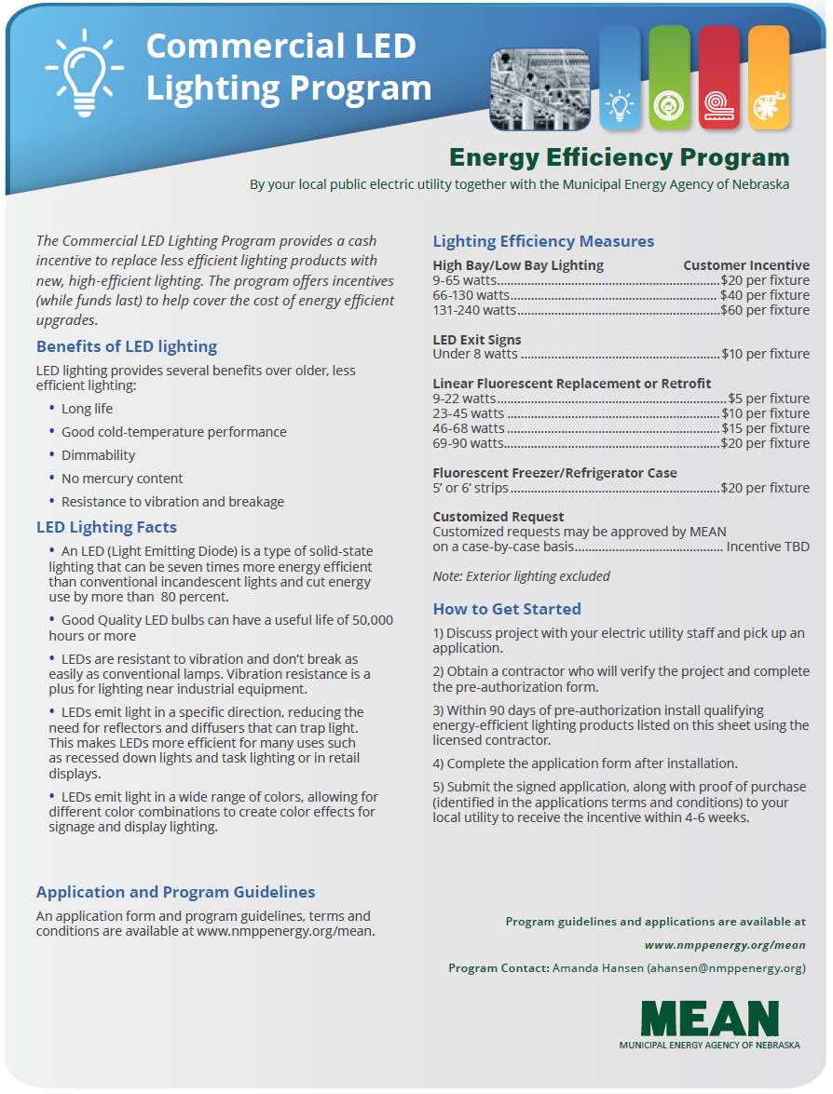

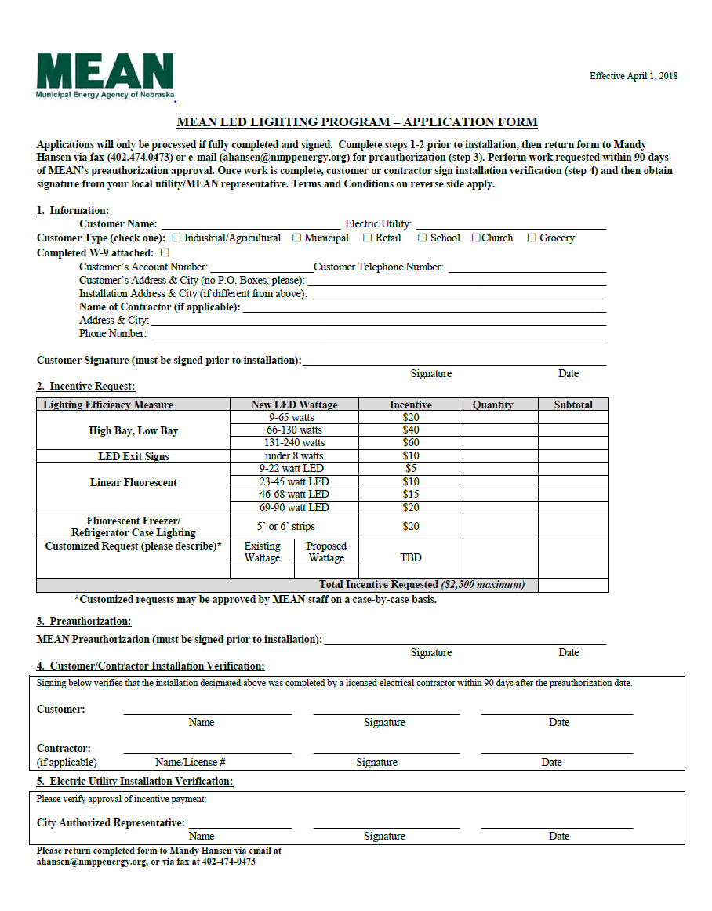

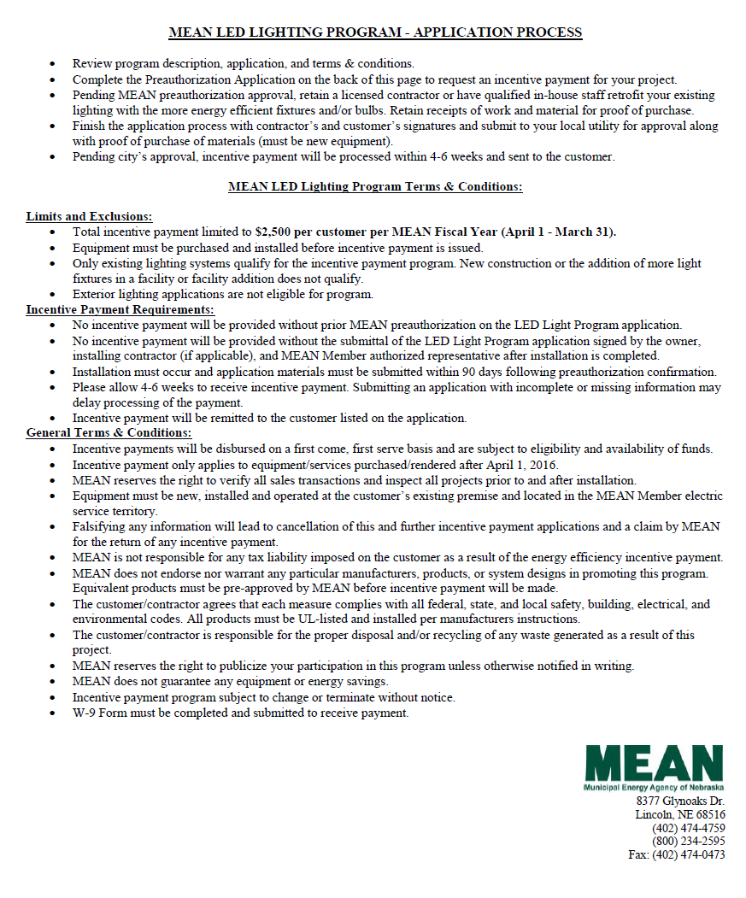

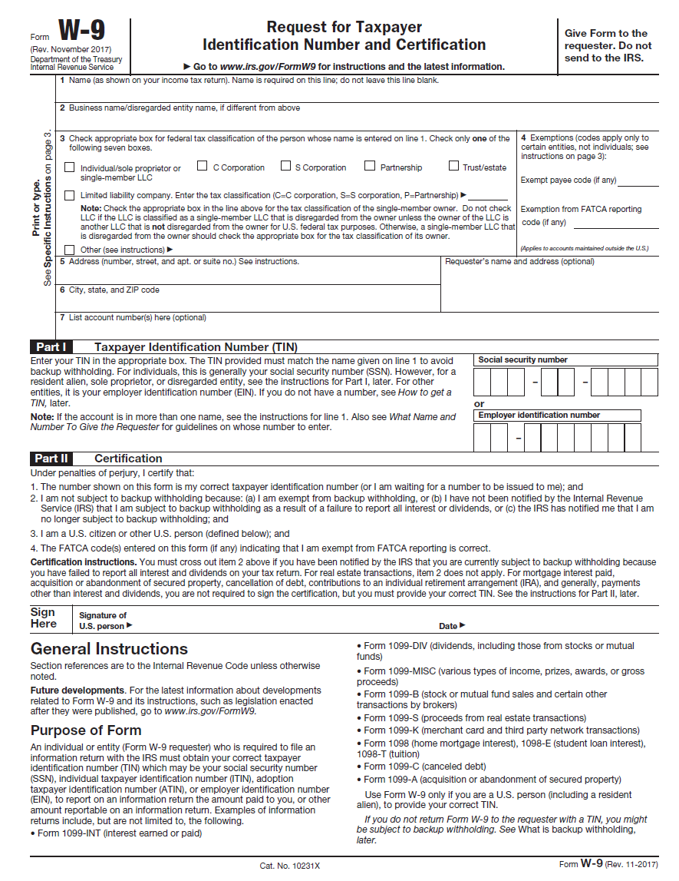

## 6.4 AR No. 4 Appendices

Appendix 6.4-A: Flow Restrictor Purchasing Information

<https://www.espwaterproducts.com/viqua-uvmax-sterilight-6-gpm-flow-restrictor-1-x-1-fnpt-frss-6/>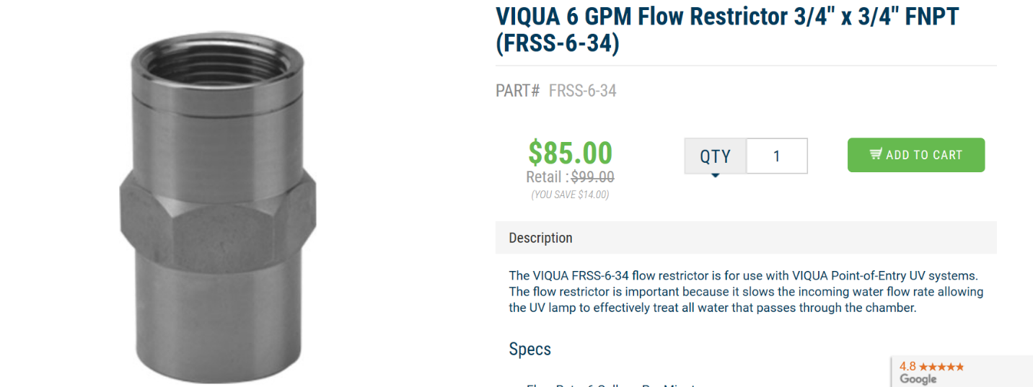

Appendix 6.4-B: Calculations for Boiler Burning Hours

**Table 6.4-1:** 2019 Total Burning Days

|  |  |  |  |  |  |  |  |  |
| --- | --- | --- | --- | --- | --- | --- | --- | --- |
| **2019 Month** | Jan | Feb | Mar | Apr | May | Jun | July | **Total** |
| **Days:** | 31 | 28 | 31 | 30 | 31 | 30 | 15 | **196** |

Assumptions:

* 196 total days of boiler operation
* 1,679 hours bacon grease has been used for fuel since January, according to Westin Packaged Meats’ Operations Manager
* Bacon grease is used for fuel approximately 5 days per week before running out

$$Daily Boiler Time=\frac{\left(\frac{\left(1,679 grease hours\right)}{\frac{5}{7} week}\right)}{196 days}$$

$$Daily Boiler Time = 11.993\frac{hours}{day}$$

$$Based on this, it is assumed the two boilers operate for a combined total of 12 hours per day.$$

## 6.5 AR No. 5 Appendices

Appendix 6.5-A: Compressed Air and Gas Institute Mattei Compressor Data Sheet

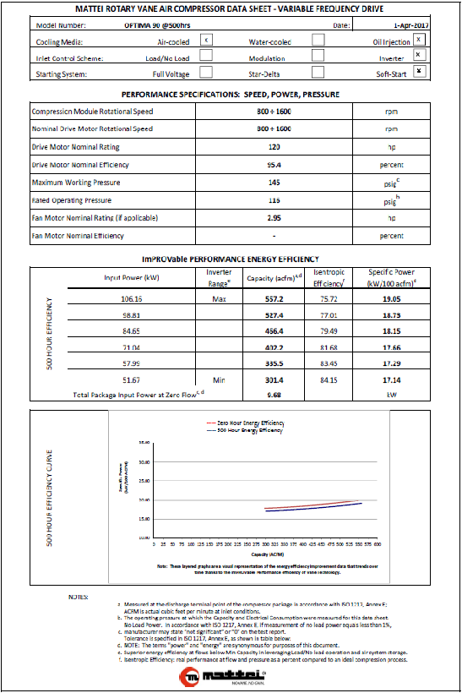

Appendix 6.5-B: Location of Leaks Correlating with Image Number in Next Appendix

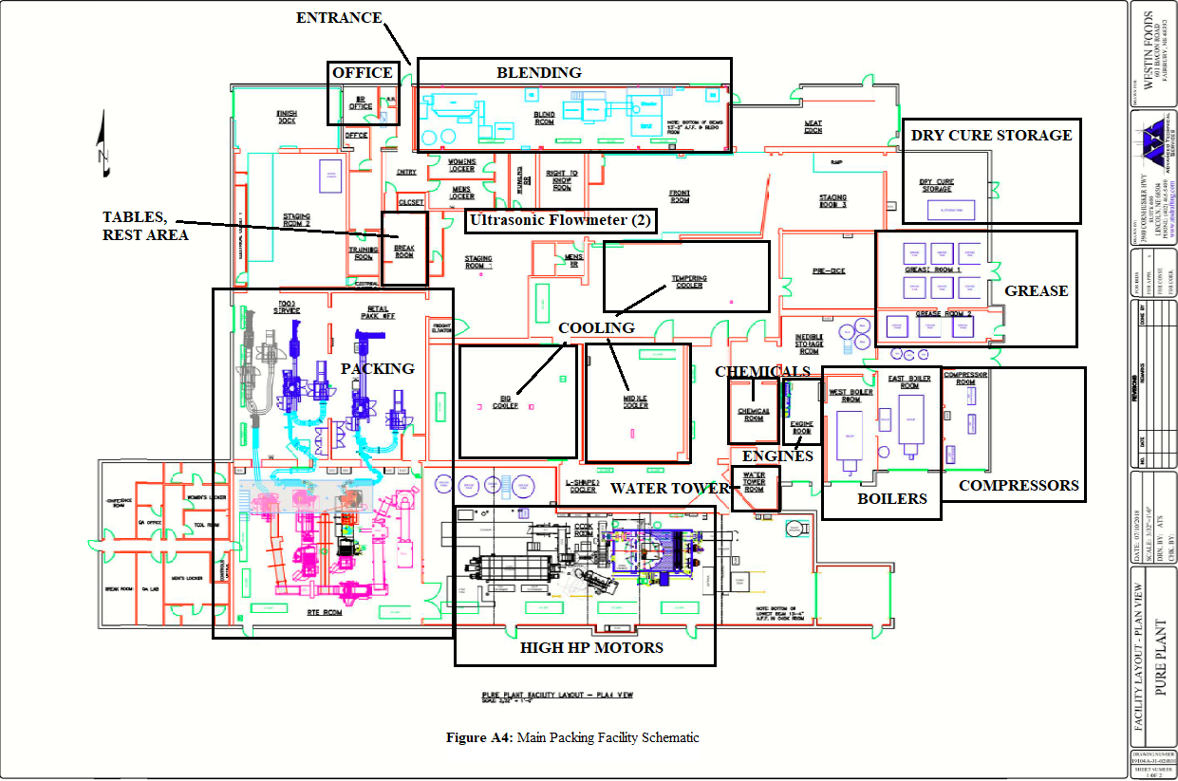

**1, 2**

**5**

**6**

**7, 8**

**9**

**10, 11**

**12**

**13, 14**

**15, 16**

**17**

**19**

Appendix 6.5-C: Summary of Leaks Located During Assessment

|  |  |
| --- | --- |
| Image 1.  Two Leaks located on 1 & 2: one on gun valve – 8.3, leak rate: 0.972 cfm. | Image 2.  One on connection between Yellow & Red Cord – 8.2, leak rate: 1.088 cfm. |
| Image 3  Unsure of location, located somewhere in packing room; “one on valve-PVC to yellow” – 8.0, leak rate: 1.32 cfm. | Image 4  Unsure of location, located somewhere in packing room; “One on machine A2 blue tube” – 8.7, leak rate: 0.624 cfm. |
| Image 5  Open blowing air leak observed in retail packing room, audible from 5 ft away, palpable upon inspection – 1/16” orifice diameter, leak rate: 8 cfm. | Image 6    Hose near door of packing and ready to eat room – 8.5, leak rate: 0.74 cfm. |
| Image 7  Leak on connector on red hosing near south side of RTE room – 8.4, leak rate: 0.856 cfm. | Image 8  Can be seen in the back of Image 7, located in same area as Image 7 - 8.8, leak rate: 0.566 cfm. |
| Image 9  By middle entrance of far north side of ready-to-eat room – 8.3, leak rate: 0.972 cfm. | Image 10  By machinery on northwest side of RTE room – 7.9, leak rate: 1.356 cfm. |
| Image 11  Located near Image 10, by machinery on northwest side of RTE room – 7.3, leak rate: 1.604. | Image 12  In Baking room – 8.5, leak rate: 0.74 cfm. |
| Image 13  In east boiler room – 7.6, leak rate: 1.464 cfm. | Image 14  Located above Image 13, audible from 5 ft away in East boiler room – 1/8” diameter, leak rate: 30 cfm. |
| Image 15  Leak located in next cell can be found on this piece of machinery in the ready to eat (RTE) room. | Image 16  Audible from 5 ft away, palpable located in RTE room – 1/16” diameter, leak rate: 8 cfm. |
| Image 17  Audible from 5 ft away, air palpable upon inspecation, located RTE room – 1/8” diameter, 30 cfm. | Image 18  Client states is not used for compressed air, but lining is leaking, did not take measurement with leak detector. |
| Image 19  Audible 8 feet away, able to feel air blow; ready to eat room – 1/8” diameter, 30 cfm. |  |

Appendix 6.5-D: Ultrasonic Leak Detector Product Information

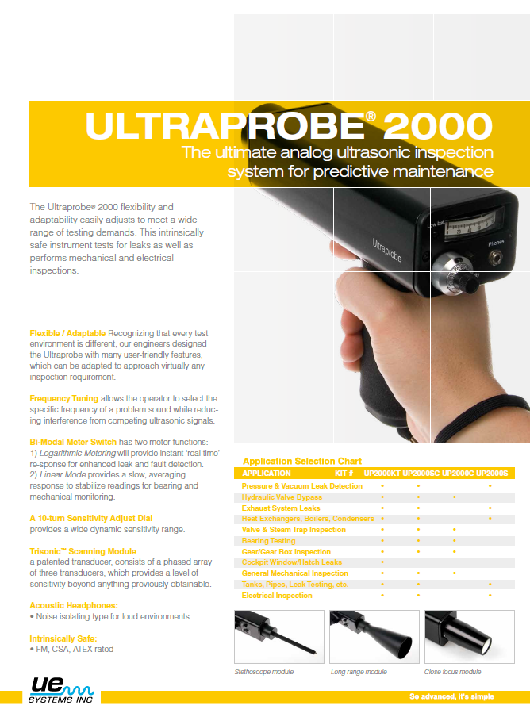

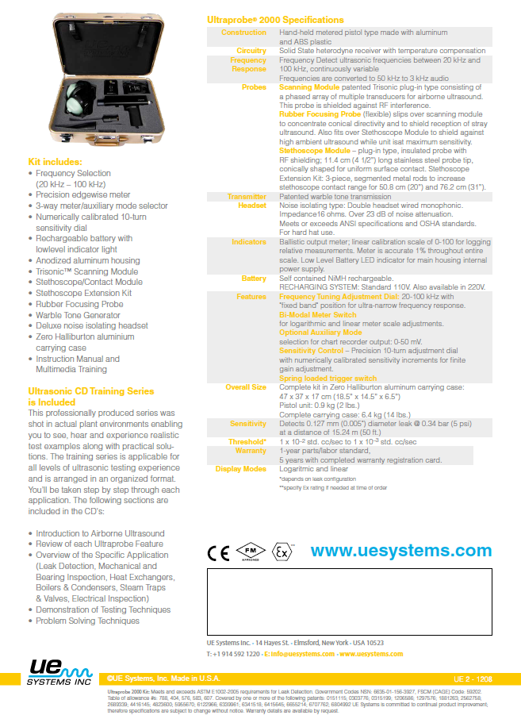



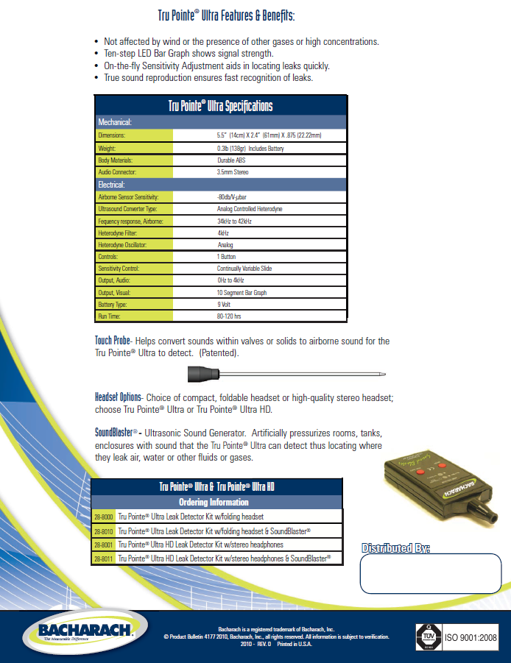

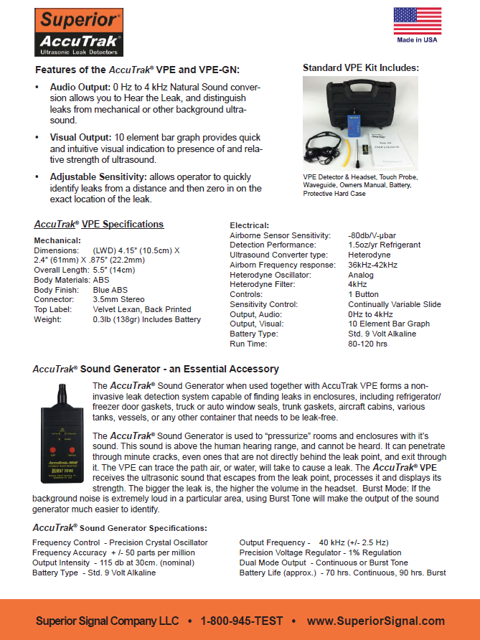

1. Website: <https://www.eia.gov/energyexplained/index.php?page=about_degree_days>
2. Mancyzk Energy Consulting, “ESTIMATING THE COST OF STEAM LOSS THROUGH THE ORIFICE OF A STEAM TRAP”. Web: http://invenoinc.com/wp-content/uploads/2017/05/Estimating-the-Steam-Loss-through-a-Orifice-of-a-Steam-Trap.pdf
3. Western Michigan University, “Property Table and Charts (English Units) Saturated Water – Pressure Table”. Web: http://homepages.wmich.edu/~cho/ME432/Appendix2_English.pdf
4. Department of Energy. “The History of the Light Bulb,” Web: https://energy.gov/articles/history-light-bulb
5. <http://www.nmppenergy.org/mean/energy-efficiency>
6. Web link: <http://www.ptonline.com/articles/energy-miser-plug-costly-compressed-air-leaks>
7. Web link: <https://energy.gov/sites/prod/files/2014/05/f16/compressed_air1.pdf>
8. *Energy Tips – Compressed Air: Minimize Compressed Air Leaks*, from the Department of Energy Compressed Air Tip Sheet #3—https://www.energy.gov/sites/prod/files/2014/05/f16/compressed_air3.pdf
9. Web link: <http://www.uesystems.com/wp-content/uploads/2012/08/compressed_air_guide.pdf>